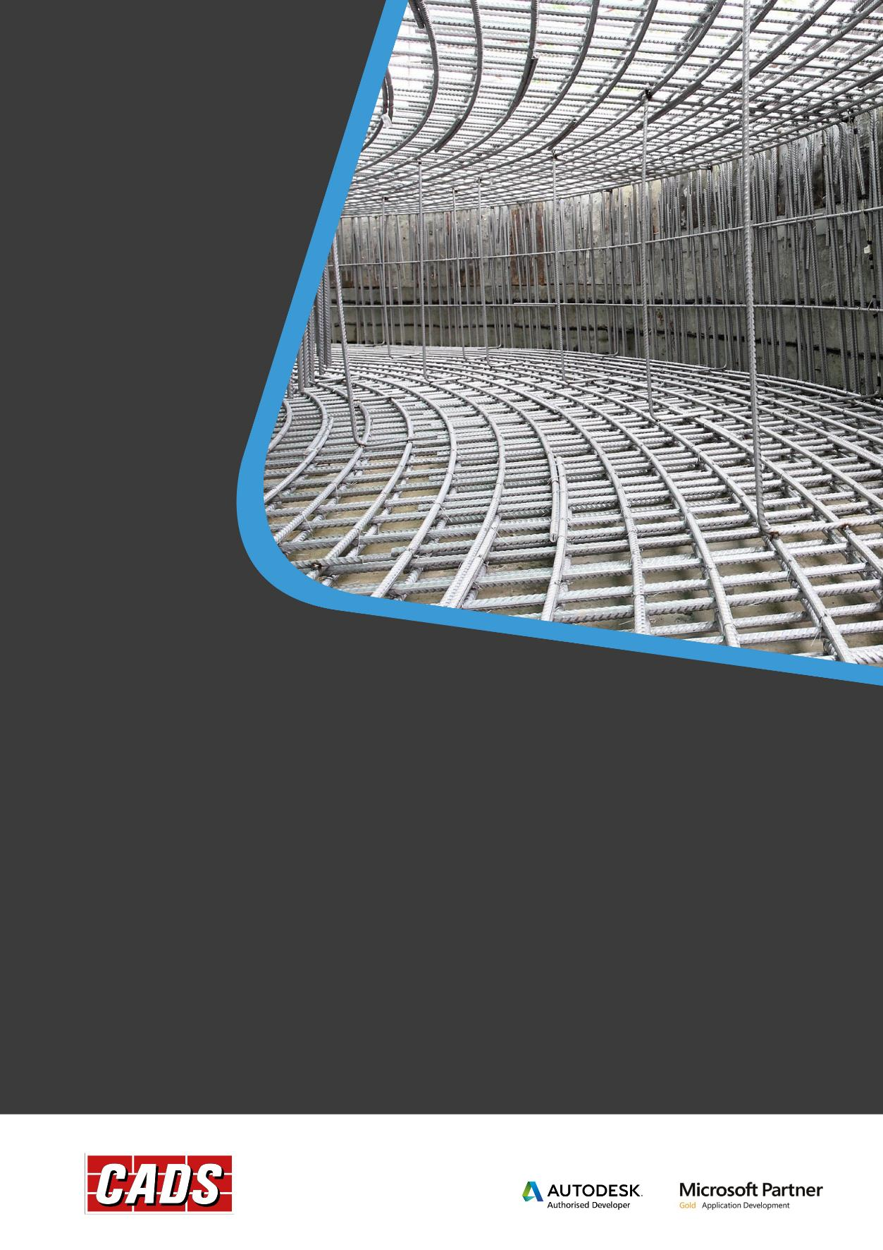
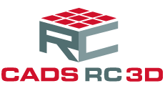
CADS Rebar Extensions for Revit®
User manual

CADS Rebar Extensions for Revit®, including all software and documentation, contains proprietary information belonging to Computer and Design Services Limited (herein referred to as “The Company”). They are provided under a license agreement containing restrictions on use and disclosure and are also protected by copyright, patent and other intellectual and industrial property laws.
Reverse engineering, disassembly or de-compilation of the software, except to the extent required to obtain interoperability with other independently created software or as specified by law is prohibited.
If you find any errors in the documentation, please report them to us in writing. The company does not warrant that this document is error free. The information contained in this document is subject to change without notice.
Except as may be expressly permitted in your license agreement, no part of this document may be reproduced or transmitted in any form or by any means, electronic or mechanical, for any purpose, without the express written permission of the company.

Contents
1 Introduction 1
2 Regional Settings 2
2.1 General 2
2.2 Databases 3
3 Automatic Reinforcement Generation 5
3.1 General Information 5
3.2 Generating Reinforcement Automatically 5
4 Beams 8
4.1 General Information 8
4.2 Beam Reinforcement Dialog 8
4.3 Generating Beam Reinforcement 10
4.3.1 Geometry 10
4.3.2 Stirrups 12
4.3.3 Stirrup Distribution 13
4.3.4 Bars – Main Top and Bottom 14
4.3.5 Additional Top & Bottom Bars 15
4.3.6 Bar Division 18
4.3.7 Reinforcement Areas 19
4.3.8 User-Defined Reinforcement 20
4.3.9 Precast Elements 21
5 Columns 22
5.1 General Information 22
5.2 Column Reinforcement Dialog 22
5.3 Generating the Column Reinforcement 24
5.3.1 Geometry 24
5.3.2 Bars 25
5.3.3 Stirrups 26
5.3.4 Additional Stirrups 27
5.3.5 Dowels 29
5.3.6 User Reinforcement 30
5.3.7 Precast Elements 31
5.3.8 Reinforcement Area 32
6 Continuous Footings 34
6.1 General Reinforcement 34
6.2 Continuous Footing Reinforcement Dialog 35
6.3 Generating the Continuous Footing Reinforcement 36
6.3.1 Geometry 36
6.3.2 Main Bars 37
6.3.3 Longitudinal Bars 38
6.3.4 Dowel Bars 39
6.3.5 User Reinforcement 40
7 Interferences of Reinforcing Bars 41
7.1 General Information 41
7.2 Rebar Interferences Analysis Dialog 42
7.3 Rebar Interferences Analysis 43
7.3.1 Interferences 43
7.3.2 Report 45
7.3.3 Graphical Viewer 46
7.3.4 How to Analyse the Rebar Interferences 46
8 Parapets 48
8.1 General Information 48
8.2 Parapet Reinforcement Dialog 49
8.3 Generating the Parapet Reinforcement 50
8.3.1 Geometry 50
8.3.2 Parapet Reinforcement 50
8.3.3 User Reinforcement 51
9 Pile Caps 53
9.1 General Information 53
9.2 Pile Cap Reinforcement Dialog 54
9.3 Generating the Pile Cap Reinforcement 54
9.3.1 Geometry 54
9.3.2 Main Bottom Bars 55
9.3.3 Main Top Bars 57
9.3.4 Circumferential Bars 57
9.3.5 Diagonal Bars 58
9.3.6 User Reinforcement 59
10 Piles 60
10.1 General Information 60
10.2 Pile Reinforcement Dialog 61
10.3 Generating the Pile Reinforcement 62
10.3.1 Geometry 62
10.3.2 Main Bars 63
10.3.3 Stirrups 64
10.3.4 Additional Reinforcement 66
10.3.5 User Reinforcement 67
11 Retaining Walls 68
11.1 General Information 68
11.2 Retaining Wall Reinforcement Dialog 69
11.3 Generating Retaining Wall Reinforcement 70
11.3.1 Geometry 70
11.3.2 Shelf Geometry 71
11.3.3 Main Bars 71
11.3.4 Distributed Reinforcement 72
11.3.5 Shelf and Key Reinforcement 73
11.3.6 User Reinforcement 74
12 Slab Corners 75
12.1 General Information 75
12.2 Slab Corner Reinforcement Dialog 76
12.3 Generating the Slab Corner Reinforcement 77
12.3.1 Geometry 77
12.3.2 Top Reinforcement 78
12.3.3 Bottom Reinforcement 79
12.3.4 User Reinforcement 80
13 Slab Openings 82
13.1 General Information 82
13.2 Slab Opening Reinforcement Dialog 83
13.3 Generating Slab Opening Reinforcement 84
13.3.1 Geometry 84
13.3.2 Main Bars 85
13.3.3 Constructional Bars 86
13.3.4 Corner Bars 87
13.3.5 User Reinforcement 88
14 Spread Footings 90
14.1 General Information 90
14.2 Spread Footing Reinforcement Dialog 91
14.3 Generating the Spread Footing Reinforcement 92
14.3.1 Geometry 92
14.3.2 Bottom Reinforcement 94
14.3.3 Top Reinforcement 95
14.3.4 Dowels 96
14.3.5 Stirrups 97
14.3.6 User Reinforcement 98
15 Wall Corners 100
15.1 General Information 100
15.2 Wall Corners Reinforcement Dialog 101
15.3 Generating Wall Corner Reinforcement 102
15.3.1 Geometry 102
15.3.2 Horizontal Bars 102
15.3.3 Longitudinal Bars 104
15.3.4 User Reinforcement 104
16 Walls 106
16.1 General Information 106
16.2 Wall Reinforcement Dialog 107
16.3 Generating Wall Reinforcement 108
16.3.1 Geometry 108
16.3.2 Distribution Bars 109
16.3.3 Dowels 111
16.3.4 Pins 112
16.3.5 Seismic Reinforcement 113
16.3.6 User Reinforcement 114
16.3.7 Precast Elements 115

Introduction
Automatically generate reinforcement using the Extension Tools for a range of standard concrete structures. Select the structural concrete elements to be reinforced, launch the appropriate tool or select the automatic generation tool. Specify the parameters to be used when reinforcing the structure. Supported concrete elements include;
- 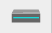 Beams
- 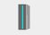 Columns
- 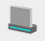 Continuous Footings
- 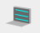 Parapets
- 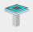 Pile caps
- 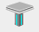 Concrete Piles
- 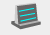 Retaining Walls
- 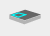 Slab Corners
- 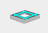 Slab Openings
- 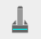 Spread Footings
- Wall Corners
- 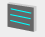 Walls

Regional Settings
Use the Regional Settings Preferences dialog to set the defaults for each of the Reinforcement Tools. Load the dialog from the File Pull Down menu and then click on Regional Settings.
The toolbar at the top of the dialog allows;
- - Settings previously saved can be loaded into the current tool.
- - Save the current settings to the regional settings.
- - Load default regional settings.
- - Save current regional settings as default.
- - Restore factory settings.

General
- Regional Settings - Set the Regional Country - Choose the country based on the detailing standard required.
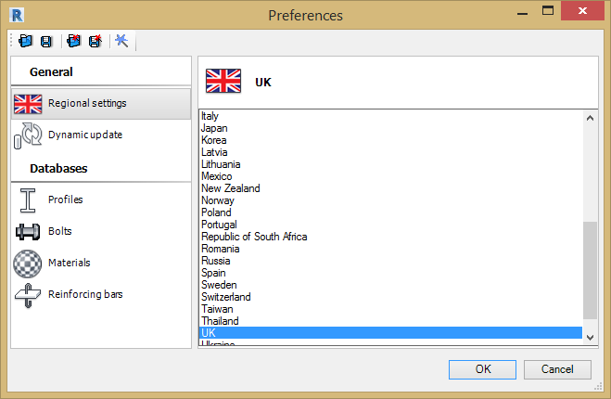
- Dynamic Update – Use this option to choose which reinforcement tools will automatically update when the Revit® model geometry changes.
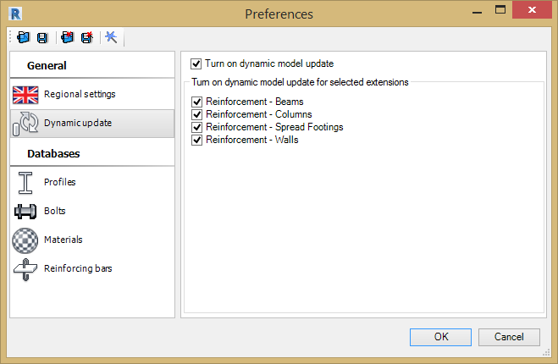

Databases
- Materials – The default materials are automatically selected based on the choice of Regional Country. Add additional materials for other countries by selecting the plus symbol.
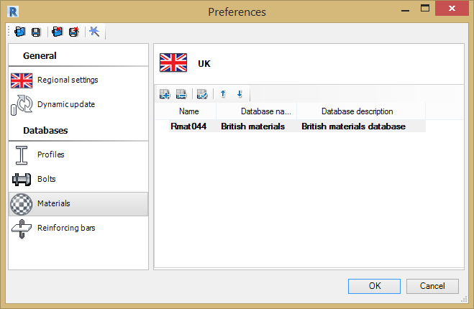
- Reinforcing Bars - Choose the detailing standard, the option is set by the Regional Country selected.
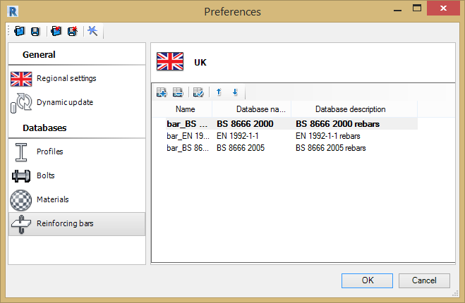

Automatic Reinforcement Generation

General Information
Use the Automatic Reinforcement Generation Tool to add reinforcement to RC elements (beams, columns, piles, etc.).
To generate the reinforcement:
- In Revit®, select the RC structural elements that require reinforcing. If the tool is selected without any elements being selected it will automatically select all elements in the model supported by the Extensions.
- Specify parameters used when generating the reinforcement.
After the Extension generates the reinforcement, messages concerning the process of generating the reinforcement for individual elements are displayed.
Note: Reinforcement can be generated for all RC elements except retaining walls and slab corners.

Generating Reinforcement Automatically
The dialog below is displayed when one or more RC structural elements have been selected in Revit® and the Automatic Reinforcement Tool is launched.
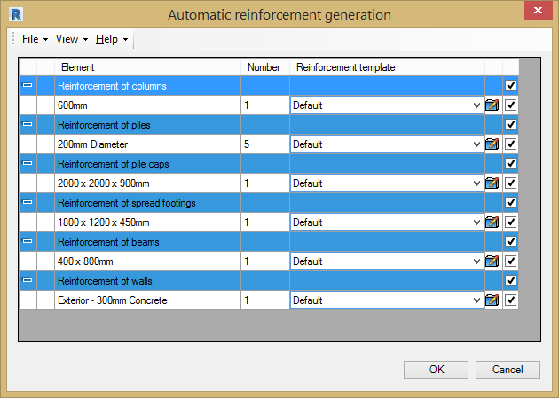
In the upper section of the dialog are the options to specify parameters for generating the reinforcement for elements of an RC structure:
Generate reinforcement for:
- The elements of an RC structure selected before launching the Extension.
- All RC elements in the project (except retaining walls and slab corners).
The dialog has several columns;
- Element – Name of RC structural element.
- Number – Number of elements selected.
- Reinforcement Template – Choose between default and predefined settings.
- Load Dialog – To load the relevant extension tool dialog for the RC Structure. Change the default reinforcement settings. Reinforcement for the element will be generated based on the amendments.
- Tick Option – Deselect to prevent reinforcement being added.
Type of generated reinforcement:
Generate the reinforcement for each structural type based on either the default setting for the tool, choosing a predefined settings file or opening the dialog for the reinforcement tool.
- Default – If the reinforcement template is set to default, the reinforcement added to the structure(s) will be based on the default settings of each tool.
- Predefined File – Click on the drop down menu in the reinforcement template column. Click on the select file option and open the predefined settings file (*.rxd). Files of preferred reinforcement layouts can be saved for each tool, this is described in the general information. Reinforcement will be generated based on these predefined settings.
Click the and buttons to expand or collapse table rows that correspond to RC elements or groups of RC elements. Use the View menu options to expand or collapse table rows.
Use the File menu options to manage template files that automatically generate the reinforcement:
- Load templates – Use this dialog to load/manage the template files used by the automatic reinforcement tool.
To search for existing templates, you can use the following options from the above dialog:
- Select files - Loads templates from a selected location. The files are added to the list in the dialog.
- Browse folder - Selects a folder on the disk which contains reinforcement templates. The templates found in the folder are added to the list in the above dialog.
To generate the reinforcement:
Click OK at the bottom of the dialog to generate reinforcement for selected (or for all) RC elements.
Note: After generating the reinforcement, any user-defined settings are not saved in the Extension.
Note: You can generate the reinforcement for all RC elements except retaining walls and slab corners.

Beams

General Information
Use the Beam Reinforcement Tool to generate reinforcement for a rectangular cross section concrete beam.
The Beam Reinforcement Tool requires a structural beam to have been placed in the model and selected before the command is loaded from the menu.
The structural beam properties define the beam dimensions, concrete grade, cover etc. The parameters for the reinforcing bars, the material, shape codes, bar diameters, hook details etc are defined inside Revit®.
Define the reinforcement parameters for the Beam Reinforcement Tool by selecting the options from the File Pull Down Menu;
- Open - Opens a file with saved reinforcement parameters.
- Save / Save As - Saves parameters to an external file. Use this file to generate reinforcement for a beam with the same geometry.
- Regional Settings - See chapter 2 for details.
- Close - Closes the Beam Reinforcement Tool.

Beam Reinforcement Dialog
The dialog for generation of reinforcement of beams has 3 main parts:
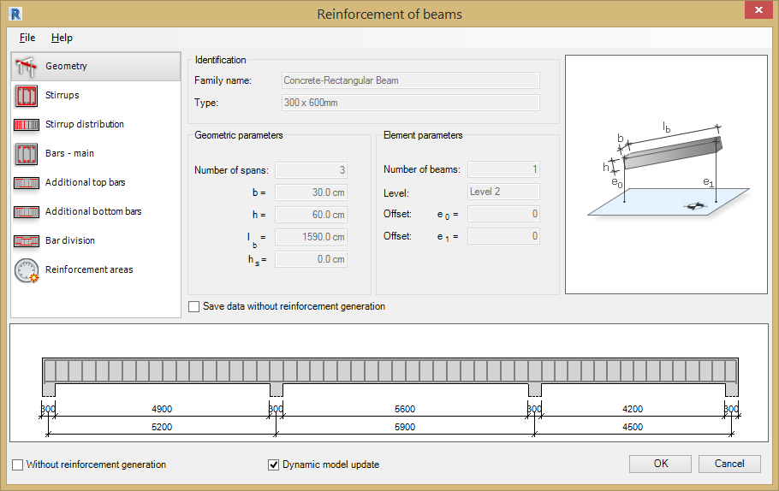
- On the left of the dialog are options for selecting components used to define beam reinforcement:
- - Geometry – Concrete section geometry parameters.
- - Stirrups - Stirrup layout parameters.
- - Stirrup Distribution – Longitudinal stirrup distribution parameters.
- - Main Bars - Top and Bottom Longitudinal reinforcement parameters.
- - Additional top bars parameters – Define additional longitudinal top bars.
- - Additional bottom bars parameters – Define additional longitudinal bottom bars.
- - Bar Division – Options to divide top and bottom bars.
- - Reinforcement Areas – Table for comparison of reinforcement areas.
- - Precast Elements - Define the additional elements required for a precast column.
- - User Defined Reinforcement – Only displayed when a selected beam already has reinforcement added.
- The area on the right of the dialog is used to define the parameters of the beam and reinforcement (depending on a selected component).
- At the bottom of the dialog is a graphical view of the defined RC beam and the generated beam reinforcement.
In the graphical view, you can select beam spans or stirrups (for example, to ensure that some of the parameters are defined only for one span of the multi-span beam), as shown below.
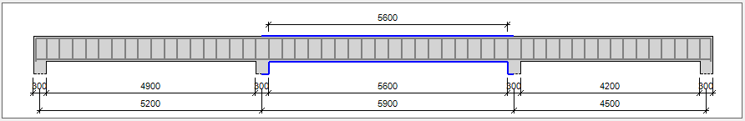
selected span
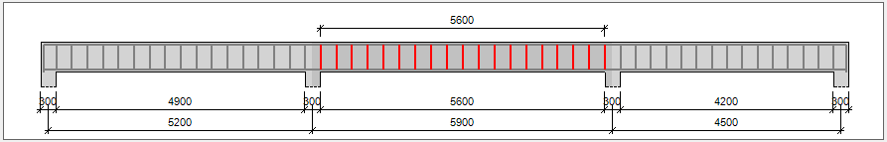
selected stirrups in the span
In the lower part of the dialog, two options are available:
- Without reinforcement generation – This option is available only if a parametric reinforcement has not been generated (i.e. reinforcement defined by means of options in the extension tabs) and there is another type of reinforcement (e.g. pre-cast elements) in the RC element. If the option is activated, the parametric reinforcement is not generated; if the option is switched off, the parametric reinforcement is generated.
- Dynamic Model Update - This option, when selected, keeps the module data up-to-date with the Revit® model.
Changing the geometry of an adjoining element or elements starts the Extension and regenerates the reinforcement to include changes.
You can deselect this option for:
- A single element (after starting the Extension clear this option at the bottom of the dialog).
- All elements of a given type in a project, such as all beams (in the Extensions preferences).
- All types of elements (in the Extensions preferences).
The Dynamic Model Update is selected by default for the whole project and all supported elements.
When you open a file, created in version 2012 or lower, this option works as follows:
- It is deselected for existing elements that were reinforced using the Extension (you can select it when modifying reinforcement using this Extension).
- It is selected by default for new elements.
Note: This option is only available if the module is launched through Revit®.

Generating Beam Reinforcement

Geometry
Define the following parameters for the section geometry in this tab:
- Identification parameters - Family and type of the beam selected, are extracted from its Revit® properties.
- Geometrical parameters - Including number of beam spans, dimensions of the cross-section, and length of the beam span.
- Element parameters - Including number of beams, position of the beam in the structure (level, offsets).
Additionally, the Beam Reinforcement Tool automatically recognises the type of supports at the beam ends.
Without reinforcement generation
- If the Save data without reinforcement generation option is not selected, the reinforcing bars are generated and displayed in Autodesk® Revit®.
- If this option is selected, the reinforcement data is generated (and can be used after restarting the Extension), but reinforcing bars cannot be displayed in the selected beam in Revit®.
Beam Reinforcement – when launched from Autodesk® Robot Structural Analysis software.
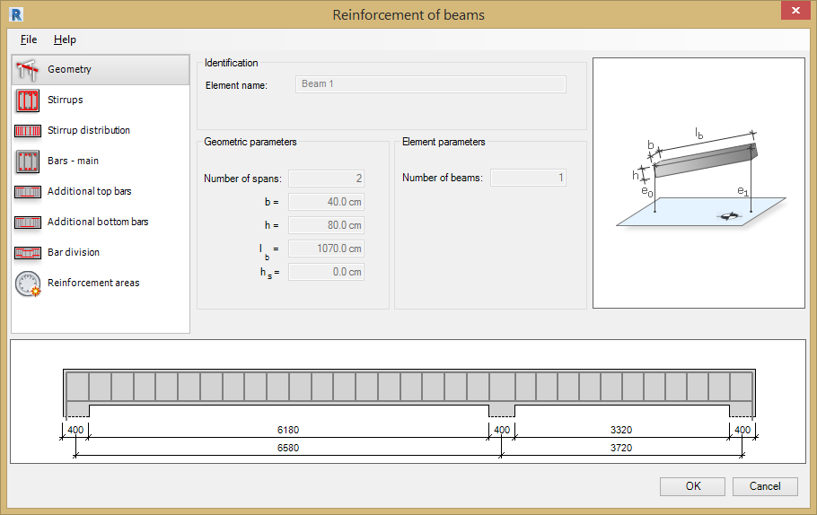
Parameters of the section geometry defined in the dialog:
- Element Name - Name of an RC structure element (beam).
- Geometric parameters - Beam dimensions: number of beam spans, dimensions of the cross-section and length of the beam span.
- Element parameters – No of Beams.
Additionally, the tool automatically recognises the type of supports at the beam ends.

Stirrups
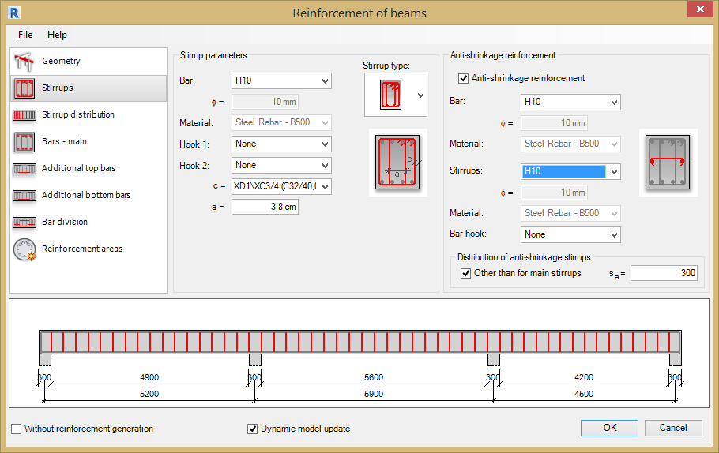
Define the following parameters for the Stirrups in the Beam Cross Section;
Stirrup parameters
- Stirrup type – choose the stirrup pattern from the following;
- Bar – Type & diameter.
- Material – Steel Grade for reinforcement.
- Hook 1 – Choose from None, 135 degrees, 90 degrees, 135 degrees seismic & 90 degrees seismic.
- Hook 2 - Choose from None, 135 degrees, 90 degrees, 135 degrees seismic & 90 degrees seismic.
- c = - Cover value (defined for each stirrup type) select the required cover from the drop down list.
- a = - Type in the value of the parameter a (defined for third and fourth stirrup types).
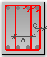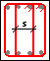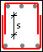
Anti-shrinkage reinforcement
- Anti-shrinkage reinforcement – Tick this option if anti-shrinkage reinforcement is required. These are stirrups and longitudinal bars (at the centre of the cross-section height).
- Bar – Select the bar grade and diameter.
- Material – Steel Grade for reinforcement.
- Stirrups – Select the bar grade and diameter.
- Material – Steel Grade for reinforcement.
- Bar Hook - Choose from None, 135 degrees, 90 degrees, 135 degrees seismic & 90 degrees seismic.
Distribution of anti-shrinkage stirrups
- Other than for main stirrups – Tick this option to set different bar centres for the anti-shrinkage stirrups.
- s a = - Type in the centre to centre value.
Note: For anti-shrinkage reinforcement, you can define:
- The same distribution as for stirrups.
- The distribution with a constant user-defined spacing.

Stirrup Distribution
The zones for the stirrup distribution are defined for each span separately. Define the following parameters for the stirrup distribution along the beam length:
Distribution type
- Uniform centres.
- 3 distribution zones (denser spacing near supports).
- 2 distribution zones.
- User-defined distribution - Type the distribution definition in the ‘s’ field.
Geometrical parameters, based on distribution type
- Uniform - Stirrup spacing s1 = Centre to centre spacing between bars.
- 3 Zone - Stirrup spacing s1 =, s2 = & s3 = - Centre to centre spacing between bars in each zone. I1 = & I3 = - the length of the first and third zones for the stirrups.
- 2 Zone - Stirrup spacing s1 = & s3 = - Centre to centre spacing between bars in each zone. I1 = - the length of the first zone for the stirrups.
- User-defined distribution s = - Type the distribution definition in the s field: 4 * 200 + 5 * 300, dR is calculated automatically for the current span according to geometrical parameters.
- dL = - Distance to first stirrup from left support.
- dR = - Distance to first stirrup from the right support.
Stirrup Distribution above the extreme Supports
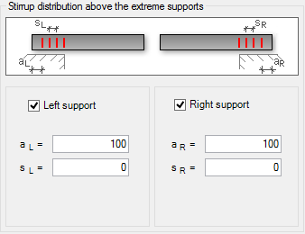
You can generate additional stirrups above supports at the beginning/end of the beam by selecting the Left support or Right support options.
- aL = Distance from the left hand end of the beam to the first stirrup.
- sL = Centre to centre distance between stirrups on the left.
- aR = Distance from the right hand end of the beam to the first stirrup.
- sR = Centre to centre distance between stirrups on the right.

Bars – Main Top and Bottom
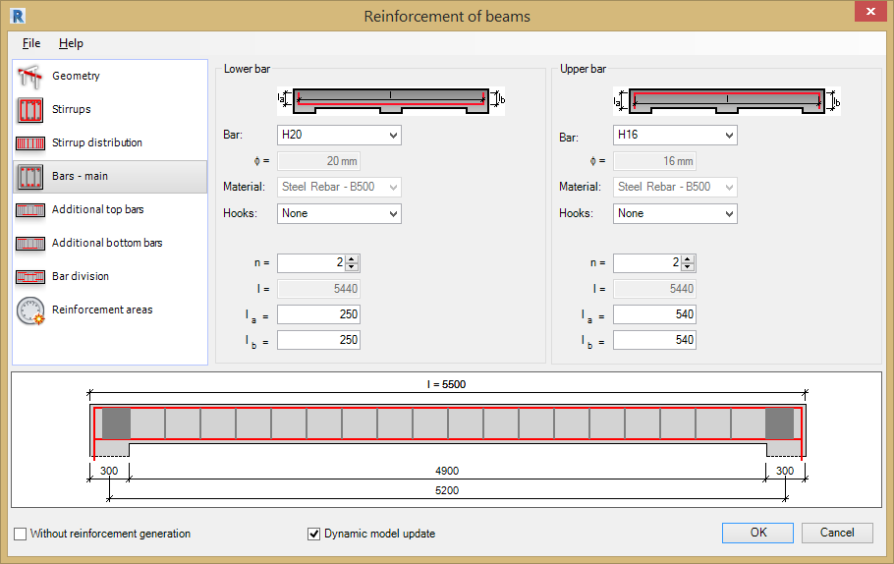
The Main Longitudinal Reinforcement is generated along the entire length of the beam. Define the following parameters for the Main Bars:
Bottom Bar Parameters
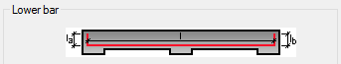
- Bar - Bar Grade and Diameter.
- Material - Steel Grade for reinforcement.
- Hooks - Choose from None, 135 degrees, 90 degrees, 135 degrees seismic & 90 degrees seismic.
- n = - Number of bottom bars.
- l= - Calculated length of bar.
- la = - Length of the left bar leg.
- lb = - Length of the right bar leg.
Top Bar Parameters
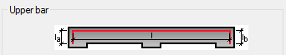
- Bar – Bar Grade and Diameter.
- Material - Steel Grade for reinforcement.
- Hooks - Choose from None, 135 degrees, 90 degrees, 135 degrees seismic & 90 degrees seismic.
- n = - Number of bottom bars.
- l= - Calculated length of bar.
- la = - Length of the left bar leg.
- lb = - Length of the right bar leg.
Note: By default, longitudinal bars are continuous along the beam length. However, they can be divided above supports, see chapter 4.3.6 Bar Division.

Additional Top & Bottom Bars
Define additional longitudinal bars using the Additional Top and Bottom Bar tabs.
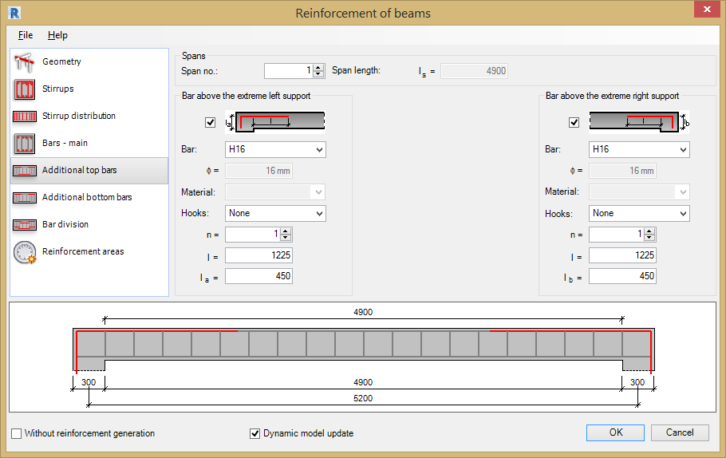
The reinforcing bars are generated separately for each beam span. Define the following parameters for the additional top bars:
Spans
- Span No: - Type in the span or use the up and down arrows to select.
- Span Length: - Reports selected span length.
Bar above extreme left support and extreme right support
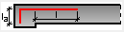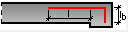
- Bar: - Bar Grade and Diameter.
- Material: - Steel Grade for reinforcement.
- Hooks: - Choose from None, 135 degrees, 90 degrees, 135 degrees seismic & 90 degrees seismic.
- n = - Type in the number of bars or use the up and down arrows to set.
- l = - Type in the length of bar leg beyond support.
- la = / lb = - Type in the length of the bar leg.
Additional Bottom Bars
The reinforcing bars are generated separately for each beam span. Define the following parameters for the additional bottom bars:
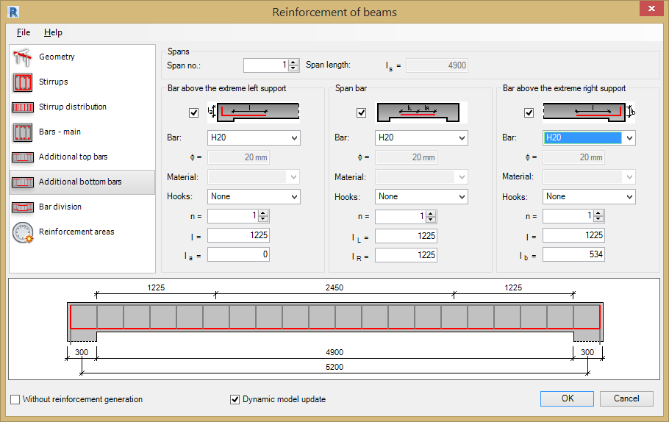
Spans
- Span No: - Type in the span or use the up and down arrows to select.
- Span Length: - Reports selected span length.
Span Bar, Bars above left and right extreme support
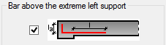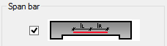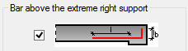
- Bar: - Bar Grade and Diameter.
- Material: - Steel Grade for reinforcement.
- Hooks: - Choose from None, 135 degrees, 90 degrees, 135 degrees seismic & 90 degrees seismic.
- n = - Type in the number of bars or use the up and down arrows to set.
- l = - Type in the length of bar leg beyond support.
- la = / lb = - Type in the length of the bar leg for left & right bars.
- lL = - Length of bar leg to the left of the centre of the span.
- lR = - Length of bar leg to the right of the centre of the span.

Bar Division
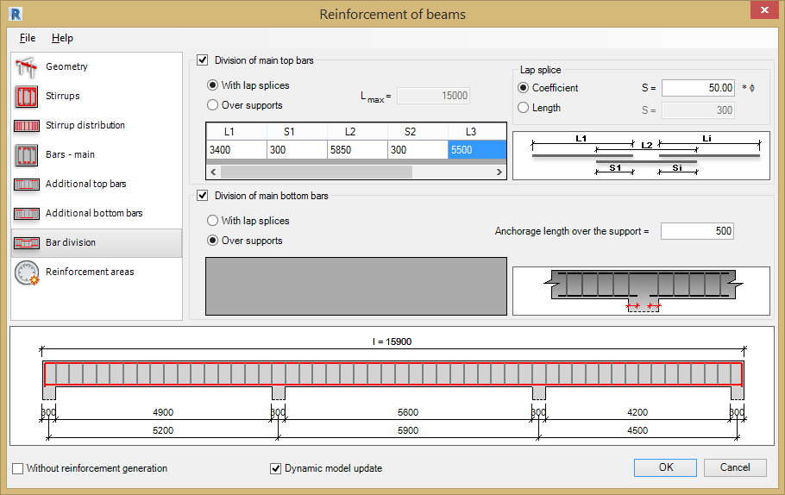
Define the lengths of the main top and bottom bars, specifying the overall lengths of the bars and lap distances with the bars over the supports. The division of Top and Bottom Bars are defined separately by two methods:
Division of Main Top and Bottom Bars
- With Lap Splices – This option is selected define the method of calculating the length of the lap length by coefficient or length.
Lap Splice
- Coefficient – Specify the lap length as a multiple of the bar diameter.
- Length = - Specify the lap length as a fixed dimension.
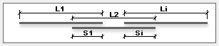
- lx – Length of top bar / bar over support.
- sx – Length of bar lap between two bars.
- lmax = Reported length of beam
- Over Supports – With this option selected type in the anchorage length.
- Anchorage length over the support – Type in the anchorage length.

Reinforcement Areas
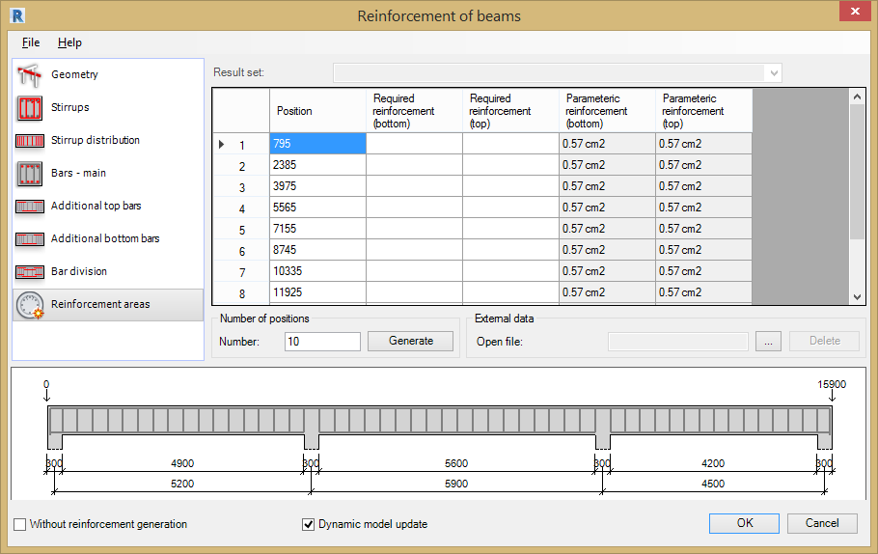
This tab displays a table where reinforcement areas for a beam can be compared:
- Required reinforcement area in selected beam sections.
- Parametric reinforcement area in selected beam sections (when reinforcement generated on base of parameters defined in the Reinforcement of beams extension).
The required reinforcement area in a beam can be defined in the table in three different ways:
- By loading the structure model from Revit®, containing information about the required reinforcement (the required reinforcement can be loaded as there is a link between the Revit® and the Robot programs - described below).
- By loading the data file; the file must be saved in MS Excel format (CSV file); in order to upload a file containing the reinforcement data, follow the steps below:
- Click the Open key located in the External data field.
- Indicate file containing the reinforcement data.
- By entering the reinforcement values directly in the table.
To get the required reinforcement areas in Revit®, use Autodesk® Robot Structural Analysis Link:
- Send model from Revit® to Robot (using the Autodesk® Robot Structural Analysis Link).
- Perform an analysis of the structure in Robot and the required reinforcement calculations for the RC elements.
- Update the model and results in Revit® (using Autodesk® Robot Structural Analysis Link).
- Main reinforcement areas will be presented in the dialog after loading the model to the Revit® project. The results received for the RC elements (required reinforcement area) will be saved in the RC elements in Revit®.
- It is possible to have several results for a single RC element. To choose a set of results use the Result Set list located above the reinforcement table.
If the file is open on the computer without the Autodesk® Robot Structural Analysis Link installed, results are not visible in the dialog. They will be visible once the Autodesk® Robot Structural Analysis has been installed.

User-Defined Reinforcement
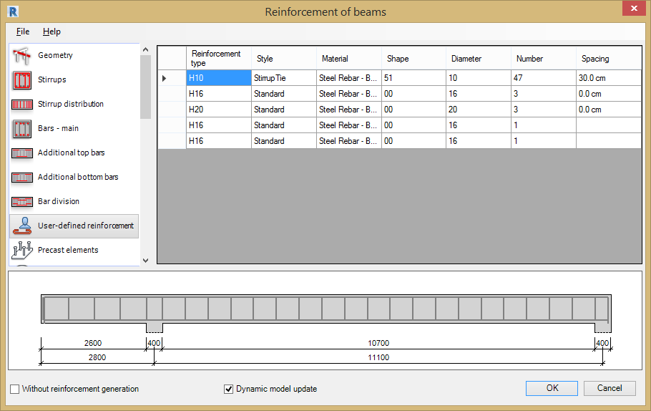
The User-defined dialog is displayed when a beam is selected that already contains reinforcement placed using the Revit® rebar tools.
The table displays information for the reinforcing bars already placed inside the beam:
- Reinforcement type - Bar Grade and Diameter.
- Style - Bar type, bent, straight or stirrup.
- Material - Steel Grade for reinforcement.
- Bar shape - Shape Code number.
- Bar diameter - Diameter of bar.
- Number - Number of bars.
- Spacing - Centre to centre spacing between bars.
The data in this table is displayed according to the rules used in Autodesk® Revit® / Autodesk® Robot Structural Analysis.

Precast Elements
The Precast Elements dialog is displayed when a precast element is selected in the Revit® model.
The options in the tab allow for generation of additional elements of the beam reinforcement - steel precast elements (mounting parts). The precast elements are steel elements, added to the RC elements of the structure for particular purposes, e.g. in order to reduce heat loss and the noise emitted.
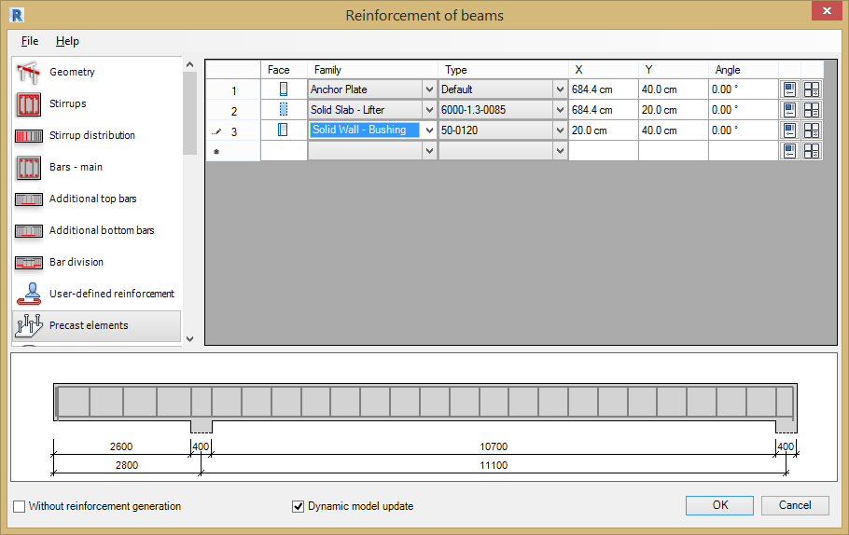
In order to define a precast element in an RC beam, follow the steps below:
- Face - From the list of the available faces of an RC element, select the section face of an RC beam; the list of available faces depends on the type of beam cross-section (rectangular section, T-section, etc.)
- Family - Select the family of the precast element.
- Type - Select the type of the precast element.
- Co-ordinates X, Y & Z - Define co-ordinates of the precast element insertion on the selected face of the element. The co-ordinates are measured in relation to the left, bottom corner of a face;
- Angle - The positive angle is clockwise.
- Properties - Define properties of a family / precast element type. Click the icons located at the end of the definition of a precast element to open dialogs containing properties of a family or the element type.

Columns

General Information
Use the Column Reinforcement Tool to generate reinforcement for rectangular and circular cross-section concrete columns.
The Column Reinforcement Tool requires a structural column to have been placed in the model and selected before the command is loaded from the menu.
The structural column properties define the beam dimensions, concrete grade, cover etc. The parameters for the reinforcing bars, the material, shape codes, bar diameters, hook details etc are defined inside Revit®.
Define the reinforcement parameters for the Column Reinforcement Tool by selecting the options from the File Pull Down Menu;
- Open - Opens a file with saved reinforcement parameters.
- Save / Save As - Saves parameters to an external file. Use this file to generate reinforcement for a beam with the same geometry.
- Regional Settings - see chapter 2 for details.
- Close - closes the Column Reinforcement Tool.

Column Reinforcement Dialog
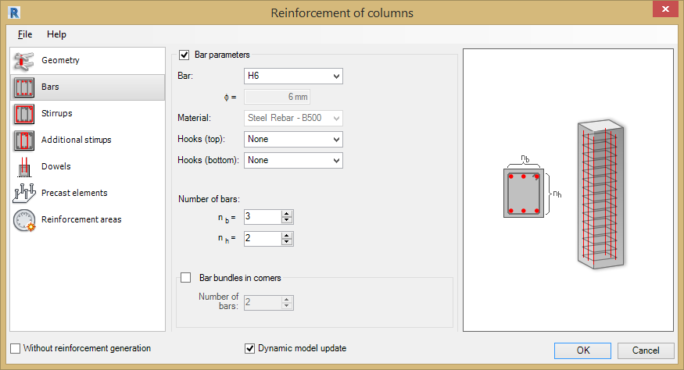
The dialog for generation of column reinforcement has 3 main areas:
- On the left of the dialog are options for selecting components used to define column reinforcement:
- Geometry – Concrete section geometry parameters.
- Bars – Define the longitudinal reinforcement.
- Stirrups - Stirrup layout parameters.
- Additional stirrups – Appears when additional main bars are added.
- Dowels – Define the Dowels and associated stirrups.
- Precast Elements – Define the additional elements required for a precast column.
- Reinforcement Areas – Table for comparison of reinforcement areas.
- User Defined Reinforcement – Only displayed when a selected beam already has reinforcement added.
- Use the area in the middle of the dialog to define the parameters of the column and reinforcement (depending on a selected component).
- On the right is a graphical view of the defined RC column and generated column reinforcement.
In the lower part of the dialog, two options are available:
- Without reinforcement generation – This option is available only in the case of a parametric reinforcement has not been generated (i.e. reinforcement defined by means of options in the extension tabs) and there is another type of reinforcement (e.g. pre-cast elements) in the RC element. If the option is activated, the parametric reinforcement is not generated; if the option is switched off, the parametric reinforcement is generated.
- Dynamic Model Update - This option, when selected, keeps the module data up-to-date with the Revit® model.
Changing the geometry of an adjoining element or elements starts the Extension and regenerates the reinforcement to include changes.
You can deselect this option for:
- A single element (after starting the Extension clear this option at the bottom of the dialog).
- All elements of a given type in a project, such as all columns(in the Extensions preferences).
- All types of elements (in the Extensions preferences).
The Dynamic Model Update is selected by default for the whole project and all supported elements.
When you open a file, created in version 2012 or lower, this option works as follows:
- It is deselected for existing elements that were reinforced using the Extension (you can select it when modifying reinforcement using this Extension).
- It is selected by default for new elements.
Note: This option is only available, if the module is launched in Revit.

Generating the Column Reinforcement

Geometry
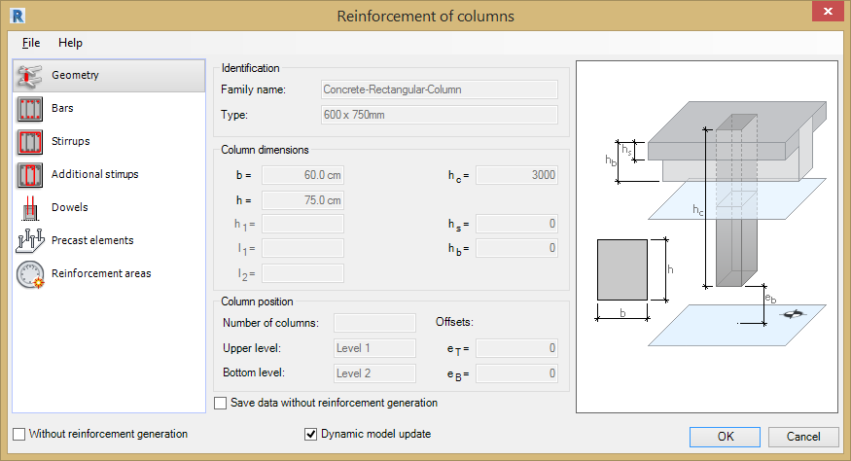
The following parameters for the column section geometry are displayed:
- Identification parameters - Family and type of the beam selected, are extracted from its Revit® properties.
- Column position - Including number of columns, position of the column in the structure (level, offsets).
Without reinforcement generation
- If the Save data without reinforcement generation option is not selected, the reinforcing bars are generated and displayed in Autodesk® Revit®.
- If this option is selected, the reinforcement data is generated (and can be used after restarting the Extension), but reinforcing bars cannot be displayed in the selected beam in Revit®.
Reinforcement of Columns - launched from Autodesk® Robot Structural Analysis
The following parameters for the column section geometry are displayed:
- Identification parameters - Family and type of the beam selected, are extracted from its Revit® properties.
- Column Dimensions - dimensions of the cross-section and column height.
The reinforcement will be generated for the following column shapes:
- - Rectangular section.
- 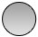 - Round section.
- 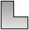 - L-shaped section.
- - T-section.
It is possible to define other types of column sections (e.g. Z-section, half-circle section etc.) but the column reinforcement will not be generated for these section types.

Bars
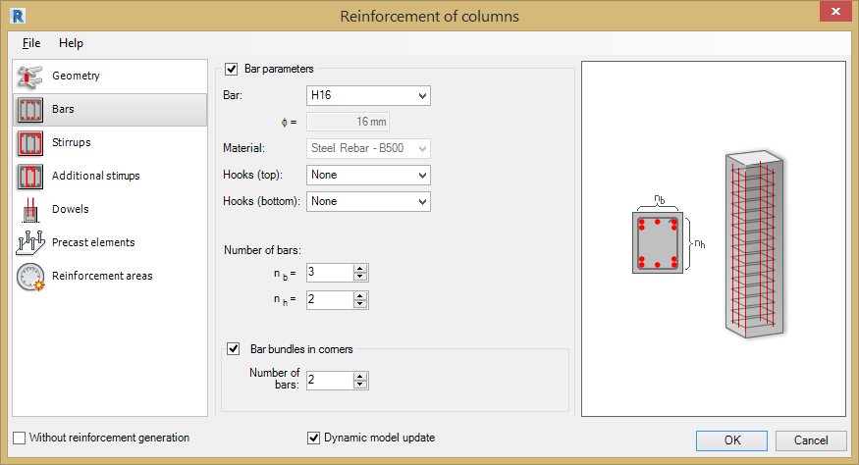
The Main Longitudinal Reinforcement is generated up the entire length of the column. Define the following parameters for the Main Bars:
Bar Parameters - Tick this option to add the main bars.
- Bar - Bar Grade and Diameter.
- Material - Steel Grade for reinforcement.
- Hooks - Choose from None, 135 degrees, 90 degrees, 135 degrees seismic & 90 degrees seismic.
Number of bars: - Tick this option to set the number of bars.
- nb = - Number of bars in the horizontal direction.
- nh = - Number of bars in the vertical direction.
Bar Bundles in corners – Tick this option to add corner bundle bars when you need to increase the reinforcement area.
- Number of bars - Set the number of bars in the bundle between 2 and 4.

Stirrups
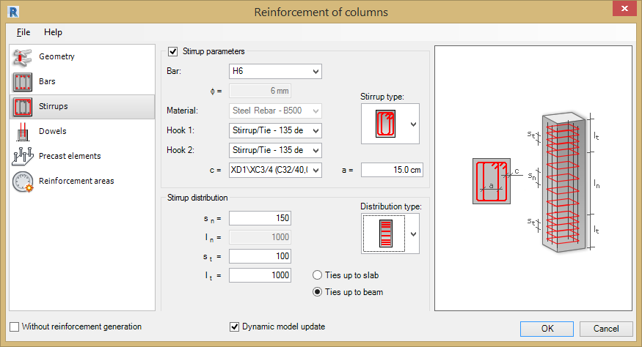
Define the following parameters for the Stirrups in the Column Cross Section;
Stirrup parameters
- Stirrup type – Choose the stirrup pattern from the following for a rectangular cross section:
- Circular Columns - There is only 1 stirrup type available for circular columns.
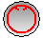
- Bar - Type & diameter.
- Material - Steel Grade for reinforcement.
- Hook 1 - Choose from None, 135 degrees, 90 degrees, 135 degrees seismic & 90 degrees seismic.
- Hook 2 - Choose from None, 135 degrees, 90 degrees, 135 degrees seismic & 90 degrees seismic.
- c = - Cover value (defined for each stirrup type) select the required cover from the drop down list.
- a = - Type in the value of the parameter a (defined for third and fourth stirrup types).
Stirrup Distribution – Select the distribution type and then set the values for the centres and zone lengths.
Distribution Type - Select the distribution type from the drop down menu.
- - Uniform centres.
- - Distribution zone with denser spacing in the lower part of the column.
- - 3 zones of stirrup distribution (denser spacing in the lower and upper parts of the column).
- sn = Stirrups centres in mid zone.
- ln = Length of mid zone.
- st = Stirrup centres in top & bottom zones.
- lt = Length of top and bottom zones.
- Ties to Slab - Tick to distribute the stirrups to the level of the slab.
- Ties to Beam - Tick to distribute the stirrups to the level of the beam.

Additional Stirrups
The Additional Stirrups tab will appear in the Component List if the number of main longitudinal bars is amended. Use this tab to select the internal horizontal and vertical stirrups. The reinforcement templates available on the drop down list will vary according to the number of main bars selected in the vertical and horizontal directions.
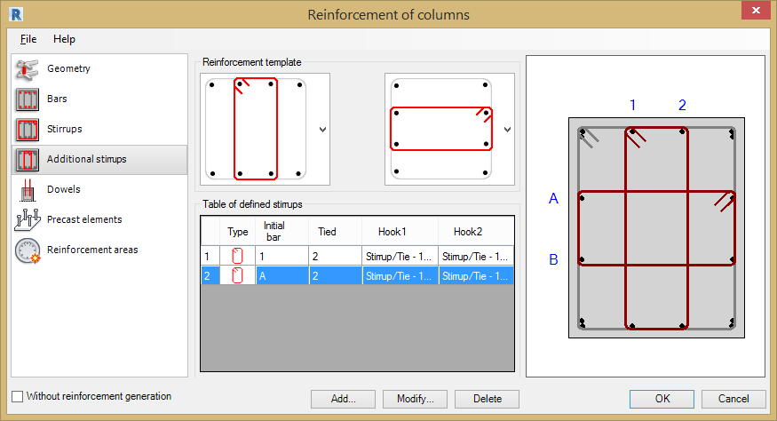
Selecting a reinforcement template in the horizontal and vertical directions generates a view of the stirrup layout on the right hand viewer pane and fills in the Table of defined stirrups.
Define additional stirrups by clicking the Add button.
- Add… - Displays the Stirrup Definition dialog.
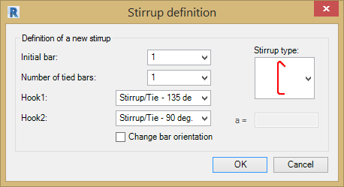
- Stirrup Type: - Choose the stirrup type from the drop down menu.
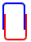
- Initial bar: - The first bar tied by the stirrup, numbers are indicated in the graphical view.
- Number of tied bars: - Number of bars tied by the stirrup in the same direction.
- Hook 1 – Choose from None, 135 degrees, 90 degrees, 135 degrees seismic & 90 degrees seismic.
- Hook 2 - Choose from None, 135 degrees, 90 degrees, 135 degrees seismic & 90 degrees seismic.
- a = - Sets the distance between stirrups.
- Change bar orientation – When ticked the hooks are flipped to the opposite direction.
Modify additional stirrups by clicking the Modify… button.
Modify… - Use this option to modify any additional stirrups that have been added to the column.
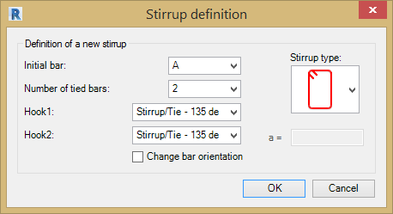
Delete - Use the Delete button to remove any stirrups appended to the column using the Add button.

Dowels
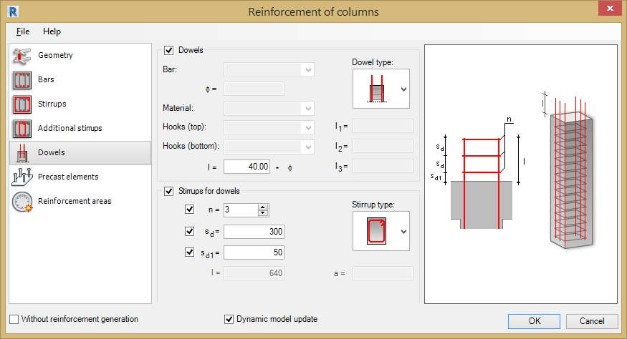

Use the Dowels tab to define the starter bars for the column. Define the following parameters for the dowels:
Dowels
- Dowels – Tick this option to add starter bars to the column.
- Dowel bar type: - Select the dowel type from the drop down menu.
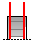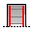
- Bar Diameter, Grade, Material and, Hooks - are all determined by the selection in the Bars Tab.
- l = Sets the length of the dowel above the beam/slab.

Stirrups for dowels
- Stirrups for dowels - The option is turned off by default.
You can define stirrups for all dowel bar types except .
Parameters for stirrups:
- Stirrup type – By default, the same as selected on the Stirrups tab:
- n = Number of stirrups n (the minimum number is 1).
- sd = Spacing between stirrups sd.
- sd1 = Distance above slab/ beam.
- l = Length of a dowel to the top of the column l (it is defined in the Dowels field).
- a = Cover value.
Stirrups are distributed from the top of the dowel bars with the spacing sd; the first stirrup from the bottom is spaced sd1 from the top of the column. Distribution is defined by manipulating with the parameters: n, sd and sd1. They are defined by the user in the fields next to the corresponding check boxes or calculated automatically (when check boxes are deselected). Listed below are the combinations of parameters defining the stirrup distribution.
- Define the number of stirrups n; stirrups are distributed evenly; sd and sd1 are calculated automatically.
- Define the number of stirrups n and spacing sd. Sd1 is calculated automatically.
- Define the number of stirrups (distributed evenly) n and spacing sd 1; sd is calculated automatically.
- Define the number of stirrups n, spacing sd and sd1; (n-1) stirrups are spaced sd from the top of the dowel; the first stirrup from the bottom of the dowel is spaced sd1 from the top of the column.
- Define the spacing sd and sd1; the number of stirrups n is calculated automatically.
- Define the spacing sd; the number of stirrups n and sd1 are calculated automatically.

User Reinforcement
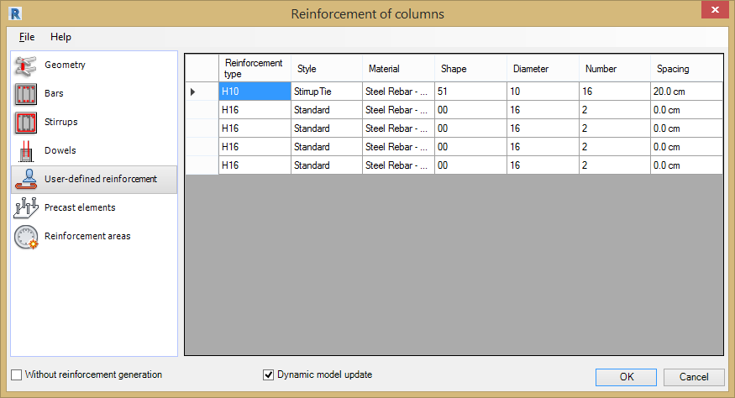
The User-defined dialog is displayed when a column is selected that already contains reinforcement placed using the Revit® rebar tools.
The table displays information for the reinforcing bars already placed inside the beam:
- Reinforcement type - Bar Grade and Diameter.
- Style - Bar type, bent, straight or stirrup.
- Material - Steel Grade for reinforcement.
- Bar shape - Shape Code number.
- Bar diameter - Diameter of bar.
- Number - Number of bars.
- Spacing - Centre to centre spacing between bars.
The data in this table is displayed according to the rules used in Autodesk® Revit® / Autodesk® Robot Structural Analysis.

Precast Elements
The Precast Elements dialog is displayed when a precast element is selected in the Revit® model.
The options in the tab allow for generation of additional elements of the column reinforcement - steel precast elements (mounting parts). The precast elements are steel elements, added to the RC elements of the structure for particular purposes, e.g. in order to reduce heat loss and noise emitted.
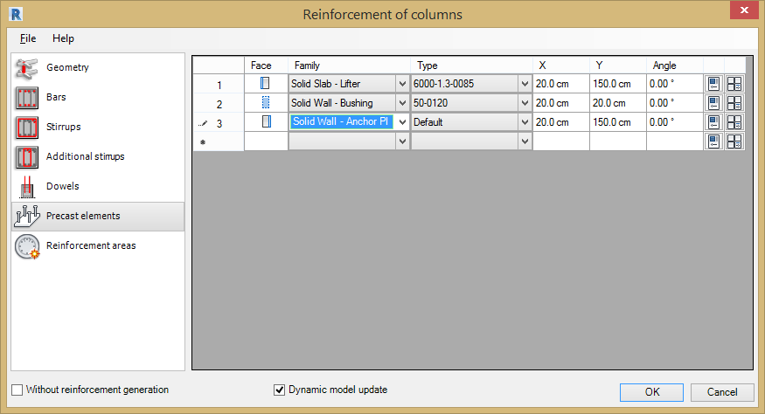
In order to define a precast element in an RC beam, follow the steps below:
- Face - From the list of the available faces of an RC element, select the section face of an RC beam; the list of available faces depends on the type of column cross-section (rectangular section, T-section, etc.).
- Family - Select the family of the precast element.
- Type - Select the type of the precast element.
- Co-ordinates X, Y & Z - Define coordinates of the precast element insertion on the selected face of the element. The coordinates are measured in relation to the left, bottom corner of a face;
- Angle - The positive angle is clockwise.
- Properties - Define properties of a family / precast element type. Click the icons located at the end of the definition of a precast element to open dialogs containing properties of a family or the element type.
Note: The option is not available for round columns.

Reinforcement Areas
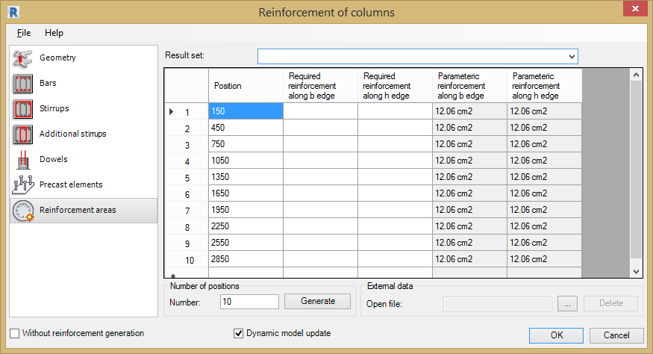
This tab displays a table where reinforcement areas for a column can be compared:
- Required reinforcement area in selected column sections.
- Parametric reinforcement area (reinforcement generated on base of parameters defined in the Reinforcement of column extension) in selected beam sections.
The required reinforcement area in a beam can be defined in the table in three different ways:
- By loading the structure model from Revit®, containing information about the required reinforcement (the required reinforcement can be loaded as there is a link between the Revit® and the Robot programs - described below).
- By loading the data file; the file must be saved in MS Excel format (CSV file); in order to upload a file containing the reinforcement data, follow the steps below:
- Click the Open key located in the External data field.
- Indicate file containing the reinforcement data.
- By entering the reinforcement values directly in the table.
To get the required reinforcement areas in Revit®, use Autodesk® Robot Structural Analysis Link:
- Send model from Revit® to Robot (using the Autodesk® Robot Structural Analysis Link).
- Perform analysis of the structure in Robot and the required reinforcement calculations for the RC elements.
- Update the model and results in Revit® (using the Autodesk® Robot Structural Analysis Link).
- Main reinforcement areas will be presented in the dialog after loading the model to the Revit® project. The results received for the RC elements (required reinforcement area) will be saved in the RC elements in Revit®.
- It is possible to have several results for a single RC element. To choose a set of results use the Result Set list located above the reinforcement table.
If the file is open on the computer without the Autodesk® Robot Structural Analysis Link installed, results are not visible in the dialog. They will be visible once the Autodesk® Robot Structural Analysis has been installed.

Continuous Footings

General Reinforcement
Use the Continuous Footing Reinforcement Tool to generate reinforcement for a continuous footing in a Revit® model.
The Continuous Footing Reinforcement Tool requires a continuous footing to have been placed in the model and selected before the command is loaded from the menu.
Reinforcement can be generated for the following types of footing cross-sections:
- Rectangular (simple and double).
- Trapezoidal.
A continuous footing can be rectilinear or curved.
The following assumptions have been adopted in the Extension:
- A continuous footing is positioned under the wall.
- Only one wall can be associated with a continuous footing.
- A wall may be positioned asymmetrically with respect to the continuous footing.
The continuous footing properties define the beam dimensions, concrete grade, cover etc. The parameters for the reinforcing bars, the material, shape codes, bar diameters, hook details etc are defined inside Revit®.
Define the reinforcement parameters for the Continuous Footing Reinforcement Tool by selecting the options from the File Pull Down Menu;
- Open - Opens a file with saved reinforcement parameters.
- Save / Save As - Saves parameters to an external file. Use this file to generate reinforcement for a beam with the same geometry.
- Regional Settings - see chapter 2 for details.
- Close - closes the Continuous Footing Reinforcement Tool.

Continuous Footing Reinforcement Dialog
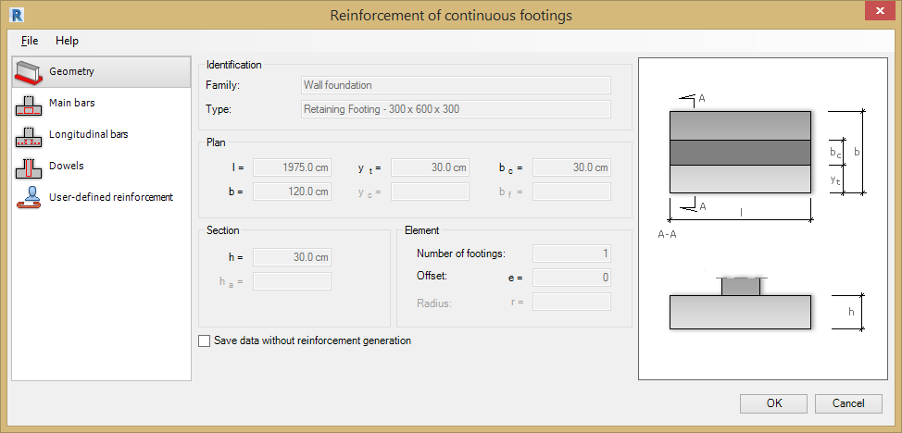
The dialog for generation of continuous footing reinforcement has 3 main areas:
- On the left are options for selecting a component used to define the continuous footing reinforcement:
- - Geometry
- - Main Bars
- - Longitudinal Bars
- - Dowel Bars
- - User Reinforcement
- In the centre, you can define parameters of the continuous footing and reinforcement (depending on a selected component).
- On the right is a graphical view of a defined continuous footing and generated footing reinforcement.

Generating the Continuous Footing Reinforcement

Geometry
The following parameters for the continuous foundation section geometry are displayed:
- Identification parameters - Family and type of a continuous footing loaded from a Revit® model.
- Plan dimensions.
- Section dimensions.
- Element parameters - Including number of footings, offset, and radius.
If the Save data without reinforcement generation option is cleared, the reinforcing bars are generated and displayed in Autodesk® Revit®. If this option is selected, the reinforcement data is generated (and can be used after restarting the Extension), but reinforcing bars cannot be displayed in Autodesk® Revit®.

Main Bars
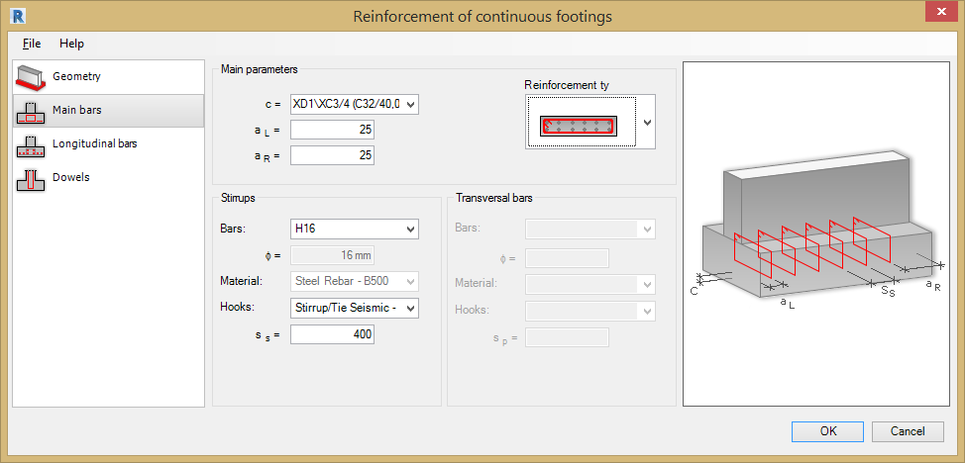
The Main Bar Reinforcement is generated along the entire length of the continuous footing. Define the following parameters for the Main Bars:
Main parameters
- c = - Cover value.
- aL = - Distance to first bar from cover on the left.
- aR = - Distance to first bar from the cover on the right.
Reinforcement type
Note For the trapezoidal cross-section, only the last 2 stirrup types are available.
Stirrups
- Bars: - Bar Grade and Diameter.
- Material - Steel Grade for reinforcement.
- Hooks - Choose from None, 135 degrees, 90 degrees, 135 degrees seismic & 90 degrees seismic.
- ss = - Centre to centre spacing.
Transversal bars
- Bars: - Bar Grade and Diameter.
- Material - Steel Grade for reinforcement.
- Hooks - Choose from None, 135 degrees, 90 degrees, 135 degrees seismic & 90 degrees seismic.
- sp = - Centre to centre spacing.
Note: Hooks and bars are loaded from families defined in Revit®.

Longitudinal Bars
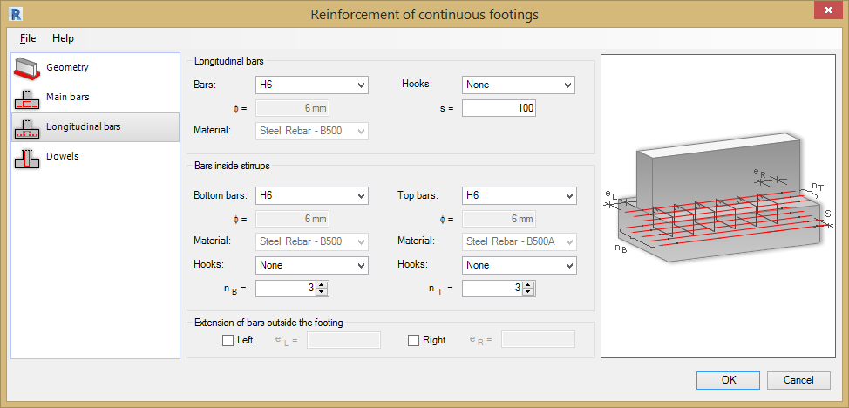
Define parameters of the longitudinal bars and the bars positioned inside stirrups (lower and upper bars).
Longitudinal Bars
- Bars: - Bar Grade and Diameter.
- Material - Steel Grade for reinforcement.
- Hooks - Choose from None, 135 degrees, 90 degrees, 135 degrees seismic & 90 degrees seismic.
- s = Centre to centre spacing.
Bars inside Stirrups
- Bottom & Top Bars - Bar Grade and Diameter.
- Material - Steel Grade for reinforcement.
- Hooks - Choose from None, 135 degrees, 90 degrees, 135 degrees seismic & 90 degrees seismic.
- ns = & nt = Centre to centre spacing of top & bottom bars.
Extension of bars outside the footing
You can also define extension parameters for bars outside the footing. Tick the left and/or the right options and enter the extension value.

Dowel Bars
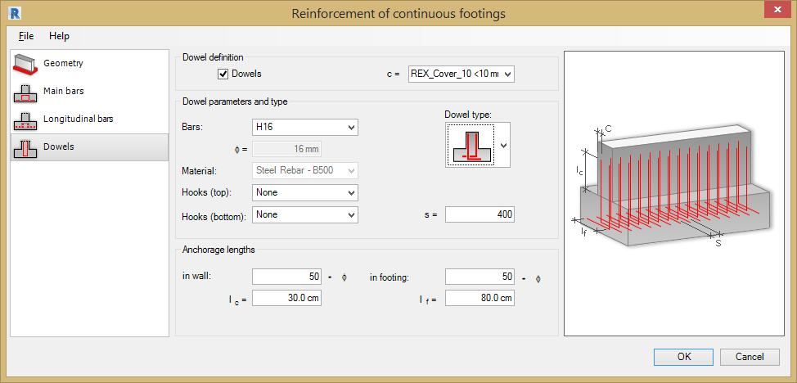
To generate dowel reinforcement in a continuous footing, under Dowel definition, select Dowels. You can then define parameters of dowel reinforcement:
Dowel definition
- c= Cover value c.
Dowel parameters and type
- Dowel type for a rectangular shape.
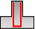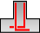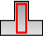
- Bar - Bar Grade and Diameter.
- Material - Steel Grade for reinforcement.
- Hooks top and bottom - Choose from None, 135 degrees, 90 degrees, 135 degrees seismic & 90 degrees seismic.
- s = Bar spacing (s).
Anchorage lengths
- ln wall - Number of bar diameters.
- lc = Length in cm.
- ln footing - Number of bar diameters.
- lf = Length in cm.
Parameters of hooks and bars are loaded from families defined in Revit®. A bar diameter and material are associated with a selected steel grade (family).

User Reinforcement
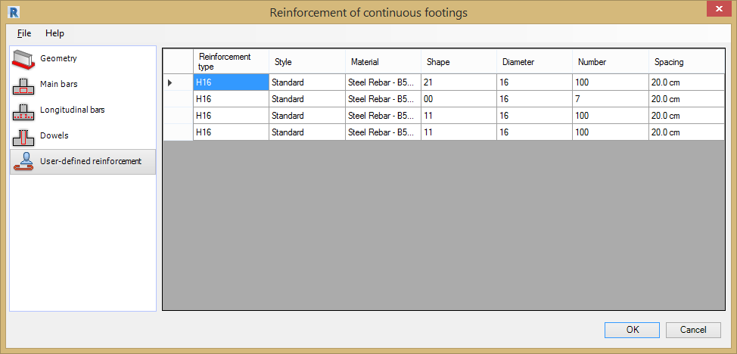
The User-defined dialog is displayed when a continuous footing is selected that already contains reinforcement placed using the Revit® rebar tools.
The table displays information for the reinforcing bars already placed inside the beam:
- Reinforcement type - Bar Grade and Diameter.
- Style - Bar type, bent, straight or stirrup.
- Material - Steel Grade for reinforcement.
- Bar shape - Shape Code number.
- Bar diameter - Diameter of bar.
- Number - Number of bars.
- Spacing - Centre to centre spacing between bars.
The data in this table is displayed according to the rules used in Autodesk® Revit®.

Interferences of Reinforcing Bars

General Information
Use the Interference of Reinforcing Bars module 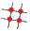 to perform an analysis of rebar clashes that exist in an RC structure model.
The tool can be used in two ways;
- Select one or more reinforced concrete elements.
- Load the tool without selecting any elements and an analysis will be performed on all reinforced elements.
Note: If only one rebar is selected, the analysis will be carried out for all the rebar in the selected RC element.
The results of the rebar interference are presented in the structure viewer or in a report (HTML format); the report can be printed out, saved in the file or sent to Microsoft Excel® or Microsoft Word®.
Limitations
Clashes are not recognised in the following circumstances:
- The common part of the intersecting rebars is smaller than 15% of the rebar diameter.
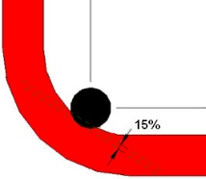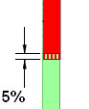
- The common part of the collinear rebars is smaller than 5% of the rebar diameter.

Rebar Interferences Analysis Dialog
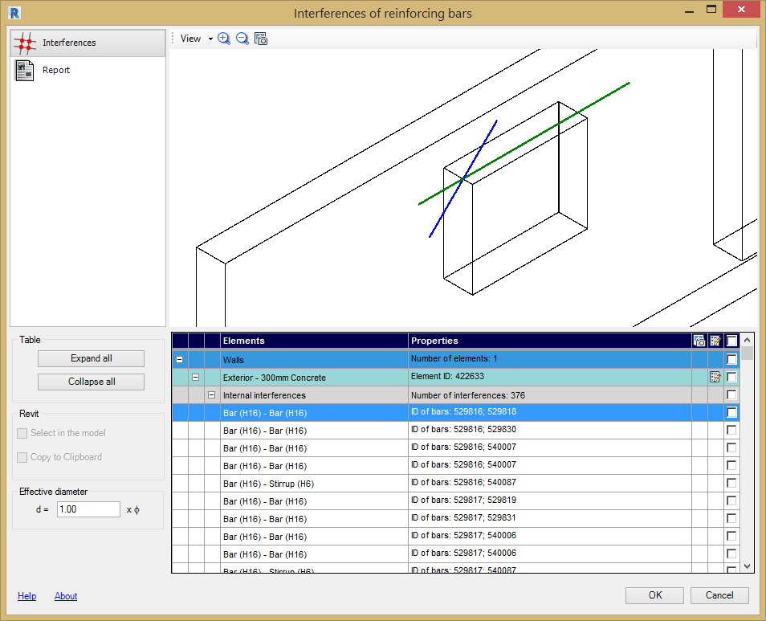
The Rebar Interference Analysis dialog is divided into three main parts:
- On the left are options for selecting the module tab. The options used to define the parameters of the interference analysis and the results display options:
  - - Rebar interferences.
  - - Report (calculation note).
- In the middle of the dialog is the graphic viewer which has a defined structure model or a generated report.
- At the bottom is a table show the clashing rebar (only available in the Interferences tab).

Rebar Interferences Analysis

Interferences
The Interferences Tab has options to display the rebar clashes in the selected structural elements.
The dialog is divided into 3 parts:
- Settings - The left-hand side containing the settings used at the interference analysis:
Table
- Expand All - Pressing this button results in expanding all the rows in the table relative to the interference of the rebars in the right, bottom corner of the dialog.
- Collapse all - Pressing this button results in collapsing of all the rows in the table relative to the interference of the rebars in the right, bottom corner of the dialog.
Revit®
- Select in the model - If this option is turned on, the rebars chosen in the interference table are selected in the Revit® structural model (the symbol appears).
- Copy to Clipboard - Activating this option copies the identification numbers of the selected rebar elements (ID) in the interference table (the symbol appears) to the Clipboard.
- Effective diameter option – Use this option to change the clash detection parameters. The tool will need to reanalyse the rebar in the structure when this value is changed.
- Rebar Interference Table - All the information in the table appears in the form of a tree; the tree consists of 5 levels:
- Model - All selected elements.
- Element type - Beam, column, slabs, foundations, etc.
- Element identifier - ID is read from the Revit® program.
- Interference type - e.g. an internal interference with indicated ID of the element.
- Interference identifier.
The table contains the following columns:
- Elements: - General name of the element is displayed.
- Properties - You can find the most important information about the element; the complete information is available in the prompt, (to open it, position the cursor in the table row).
- Screen capture: - This icon will be displayed in the table row if a screen capture of the clash has been taken using the Capture Icon in the top toolbar menu. To capture the image select the interference on the table and then click the capture icon.
- If the icon is displayed in the table row, pressing it activates the extension tool that was used to generate the reinforcement for the RC element (e.g. beam, column). Modifications of the reinforcement in the element can then be made.
- If the option is turned on in the last column , it means that the element located in this table row will be included in the report (calculation note).
Note: The screen capture can only be performed for a highlighted element (selected with the mouse cursor) in the table of the rebars interference.
Note: If a structure element contains radial reinforcement (e.g. the distribution of stirrups presented in the picture below), the longitudinal rebar intersects with all the stirrups. As many interferences (with the same ID number) as the stirrups are created.
- Graphical Viewer - There are two ways of presenting a clash in the graphical viewer:
- Presentation - Of all the interferences for a selected element.
- Detail Presentation - For a selected interference.
To switch from one viewer type to another, follow the steps below:
- All the interferences -> Details: left-click the symbol ... for a selected interference.
- Details -> All the interferences: press the ESC button.
Note: The interferences in the graphic viewer are not presented for all the elements, but for one selected element only. An element may be selected:
- Graphically - By left-clicking the mouse.
- In the table - Indicating the row in the interference table.

Report
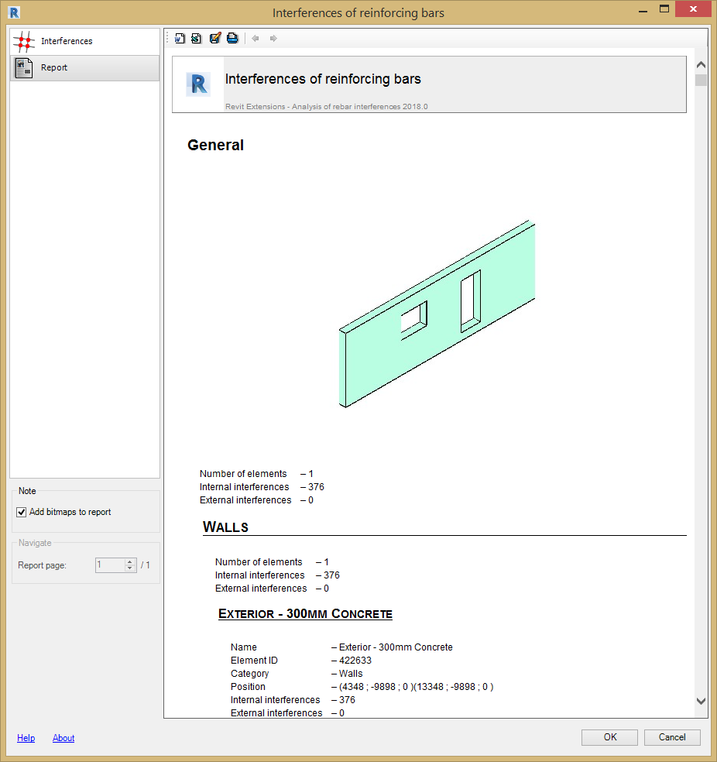
Use the Report tab to display results for the analysed rebar clashes in the form of a calculation note. The dialog in this tab has 2 parts:
- Report Viewer - from the menu in the upper part of the dialog you can specify the following options:
- Export to MS Word - Sends a note to a Microsoft Word® document.
- Export to MS Excel - Sends a note to a Microsoft Excel® document.
- Save as HTML - Saves the report in HTML format (MHT).
- Print - Prints a note.
- Previous & Next - Allows to present previous/next page of the report.
Note: The export and printing options are applicable to the currently displayed page of the report.
- Settings - The lower left of the dialog holds the following options:
- Add bitmaps to report - If this option is activated, the screen captures made so far are attached to the note (report). This option allows viewing the report pages. Only one page of the report may be presented on screen.
Note: One report page is not equal to one page of printing; the interferences of the same type are presented on the same report page.

Graphical Viewer
The graphical viewer is available on the Interferences tab. A View menu is available for the graphical viewer contain various view controls.
View - This menu has the following options:
- Zoom All - Zooms to a view of the entire model.
- Zoom Window - Zooms in a selected rectangular area.
- Zoom in - Zooms in the view.
- Zoom out - Zooms out the view.
- Automatic zoom – The view size is automatically adjusted to the current selection.
- Screen capture option is available.
Navigation between the elements:
Element selection in the view; navigation in accordance with the element hierarchy:
- Whole model.
- Element category (e.g. column, beam).
- Element instance (e.g. column id = xxxx).
- Interference type (e.g. internal).
- Selected interference.
Element selection directly in the rebars interference table.
Standard options in the view are available with the mouse:
- Middle button pressed + move - move view.
- Scroll - zoom in, zoom out.
- Middle button pressed + shift + move - rotate view.
- Pressing the left button - select element.

How to Analyse the Rebar Interferences
To analyse the rebar clashing interference and generate a calculation note, follow the steps below:
- In a structural model, select the elements for which the interference analysis is to be carried out (if the elements are not selected all the elements are included in the interference analysis).
- Activate the extension to analyse the rebars interferences.
- Determine which interferences should be viewed and for which screen captures should be made (the row in the interference table should be highlighted and screen capture for selected interference should be performed, if necessary).
- Determine which interferences are to be included in the calculation note (appears in the last column of the interference table for the table row to be taken in consideration in the note).
- Save / print the calculation note.

Parapets

General Information
The Parapet Tool generates reinforcement of a parapet defined in a Revit® model. Reinforcement can be generated for the following types of parapet cross-section:
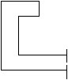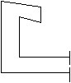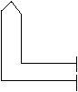
The vertical element of the parapet must be defined as a beam or wall.
The Parapet Reinforcement Tool requires a parapet to have been placed in the model and selected before the command is loaded from the menu as shown in the image below:
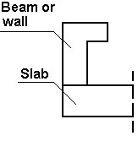
If the vertical element of the parapet is defined as a wall. The Wall Reinforcement Tool can be used for which you defined an additional (rectangle or parallelogram-shaped) section using the Sweeps option selected from the Element properties dialog.
The Parapet Tool loads the necessary information from Revit®:
- Parapet geometry.
- The parameters of reinforcing bars (diameter, material, reinforcement hooks).
Define the reinforcement parameters for the Parapet Reinforcement Tool by selecting the options from the File Pull Down Menu;
- Open - Opens a file with saved reinforcement parameters.
- Save / Save As - Saves parameters to an external file. Use this file to generate reinforcement for a beam with the same geometry.
- Regional Settings - See chapter 2 for details.
- Close - Closes the Parapet Reinforcement Tool.

Parapet Reinforcement Dialog
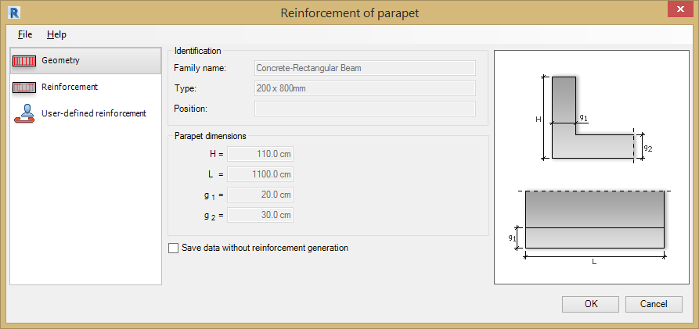
The dialog for the parapet reinforcement has 3 main areas:
- On the left of the dialog are options for selecting components used to define parapet reinforcement:
- Geometry – Concrete section geometry parameters.
- Reinforcement – Define longitudinal and transverse reinforcement.
- User Reinforcement
- In the centre, define parameters of the continuous footing and reinforcement (depending on a selected component).
- On the right is a graphical view of a defined continuous footing and generated footing reinforcement.

Generating the Parapet Reinforcement

Geometry
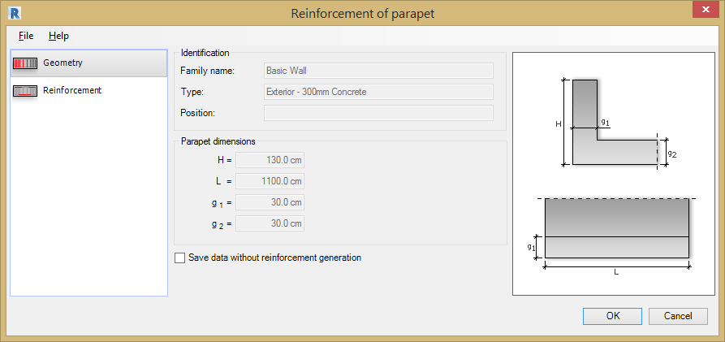
The following parameters for the parapet section geometry are displayed:
- Identification - Displays the parameters identifying the parapet (name, type, position), these are loaded from the Revit® model.
- Parapet Dimensions - Displays a number of dimensions dependent on the selected parapet shape.
If the Save data without reinforcement generation option is cleared, the reinforcing bars are generated and displayed in Autodesk® Revit®. If this option is selected, the reinforcement data is generated (and can be used after restarting the Extension), but reinforcing bars cannot be displayed in Autodesk® Revit®.

Parapet Reinforcement
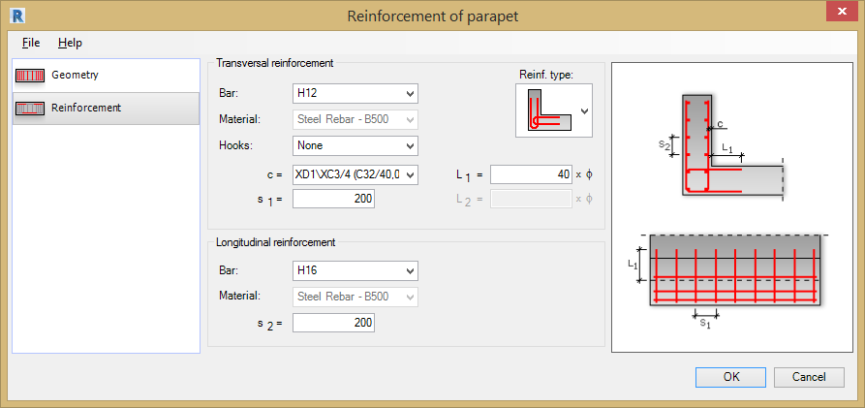
Define the following parapet reinforcement:
Transversal Reinforcement:
- Reinforcement Type -
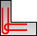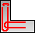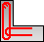
- Bars - Bar Grade and Diameter.
- Material - Steel Grade for reinforcement.
- Hooks - Choose from None, 135 degrees, 90 degrees, 135 degrees seismic & 90 degrees seismic.
- c = Cover value c for transversal bars.
- s1 = Bar spacing.
- L1 & L2 = Anchorage length for the bars.
Longitudinal Reinforcement:
- Bar Type - Bar Grade and Diameter.
- Material - Steel Grade for reinforcement.
- s2 = Spacing of the longitudinal bars.

User Reinforcement
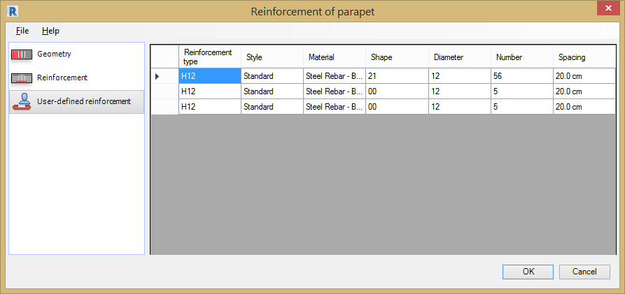
The User-defined dialog is displayed when a parapet is selected that already contains reinforcement placed using the Revit® rebar tools.
The table displays information for the reinforcing bars already placed inside the beam:
- Reinforcement type - Bar Grade and Diameter.
- Style - Bar type, bent, straight or stirrup.
- Material - Steel Grade for reinforcement.
- Bar shape - Shape Code number.
- Bar diameter - Diameter of bar.
- Number - Number of bars.
- Spacing - Centre to centre spacing between bars.
The data in this table is displayed according to the rules used in Autodesk® Revit®.

Pile Caps

General Information
The Pile Cap Reinforcement Tool generates reinforcement for a pile cap in a Revit® model. It is possible to generate reinforcement for rectangular and triangular sections of a pile cap (seen as projected).
The pile cap information is extracted from the selected element in the Revit® model:
- Geometry of pile cap.
- Geometry of foundation piles positioned under the pile cap.
- Parameters (diameter, material, reinforcement hooks) of reinforcing bars).
Using the Pile Cap Reinforcement Tool to define the pile cap reinforcement:
- When there is rectangular distribution of piles under the pile cap.
- When there is arbitrary distribution of piles under the pile cap.
- When a pile cap is a separate object (without piles under it).
Define the reinforcement parameters for the Pile Cap Reinforcement Tool by selecting the options from the File Pull Down Menu;
- Open - Opens a file with saved reinforcement parameters.
- Save / Save As - Saves parameters to an external file. Use this file to generate reinforcement for a pile cap with the same geometry.
- Regional Settings - See chapter 2 for details.
- Close - Closes the Pile Cap Reinforcement Tool.

Pile Cap Reinforcement Dialog
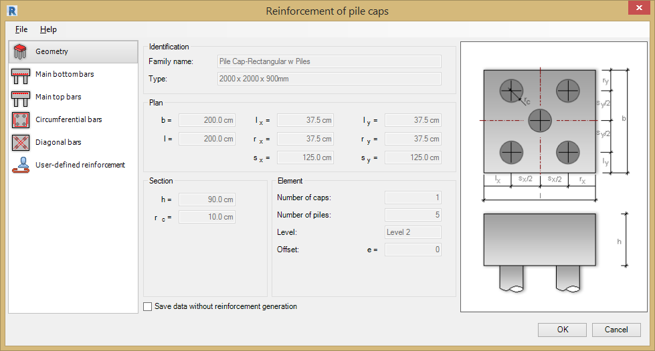
The dialog for generation of pile cap reinforcement has 3 main parts:
On the left are options for selecting a component used to define pile cap reinforcement:
- - Pile cap geometry.
- - Main bottom bars.
- - Main top bars.
- - Circumferential bars.
- - Diagonal bars.
- - User Defined Reinforcement
In the centre, define parameters of the pile cap and reinforcement (depending on a selected component).
On the right is a graphical view of a defined pile cap and generated pile cap reinforcement.

Generating the Pile Cap Reinforcement

Geometry
The Pile Cap Geometry parameters are displayed in the geometry tab:
- Identification parameters - Family and type of a pile cap loaded from a Revit® model.
- Plan - The dimensions of the pile cap, these will vary according to the pile cap type selected.
- Section - The dimensions of the pile cap, these will vary according to pile cap type selected.
- Element - Displays the number of pile caps, number of piles, level, and offset.
The Pile Cap Reinforcement Tool will work with the following pile cap shapes:
Rectangular
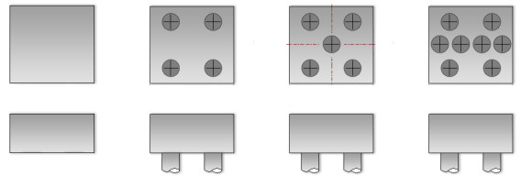
Triangular
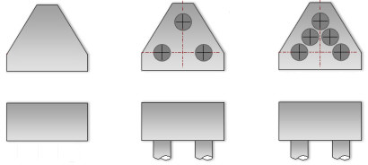
If the Save data without reinforcement generation option is cleared, the reinforcing bars are generated and displayed in Autodesk® Revit®. If this option is selected, the reinforcement data is generated (and can be used after restarting the Extension), but reinforcing bars cannot be displayed in Autodesk® Revit®.

Main Bottom Bars
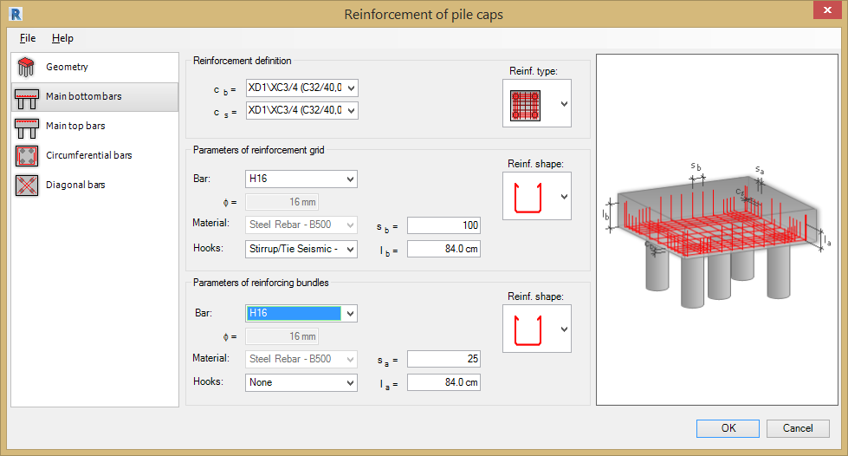
Define the following parameters for the Main Bottom Bars for the Pile Cap:
Reinforcement definition
- cb = Enter the cover distance to the bottom of the pile cap.
- cs = Enter the cover distance to the side of the pile cap.
- Reinforcement type - Select the reinforcement arrangement from the drop down menu.
Pile Cap Reinforcement - Limited to zones above the piles (reinforcement by means of reinforcing bundles): it can be applied only to regular distances between piles.
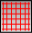 Reinforcement Grid - On the entire surface of a pile cap (it can be applied to all types of pile caps);
Note: These are not prefabricated reinforcement grids (grids are not distributed in the pile cap).
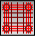 Mixed type of pile cap reinforcement - It can be applied identically as the first reinforcement type.
Reinforcement Grid Parameters
- Reinforcement shape - Choose the shape code from the drop down menu.
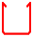
- Bars - Bar Grade and Diameter.
- Material - Steel Grade for reinforcement.
- Hooks - Choose from None, 135 degrees, 90 degrees, 135 degrees seismic & 90 degrees seismic.
- sb = Centre to centre spacing.
- lb = Leg length.
Reinforcing Bundles Parameters
- Reinforcement shape - The shape displayed depends on a selected reinforcement type):
- Bars -Bar Grade and Diameter.
- Material - Steel Grade for reinforcement.
- Hooks - Choose from None, 135 degrees, 90 degrees, 135 degrees seismic & 90 degrees seismic.
- sa = Centre to centre spacing.
- la = Leg length.

Main Top Bars
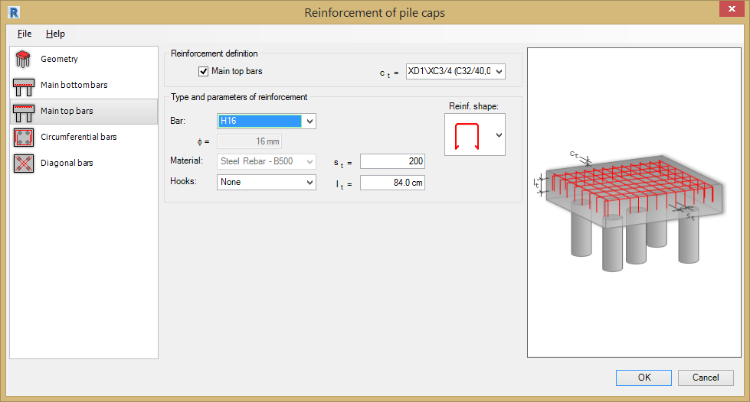
To generate main top reinforcement for the pile cap, under Reinforcement definition, select Main top bars. Define parameters of main top reinforcement.
Type and parameters of main top reinforcement
- ct = Cover to the top reinforcement.
- Reinforcement shape - Choose the shape from the drop down menu.
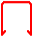
- Bars - Bar Grade and Diameter.
- Material - Steel Grade for reinforcement.
- Hooks - Choose from None, 135 degrees, 90 degrees, 135 degrees seismic & 90 degrees seismic.
- st = Centre to centre spacing.
- lt = Leg length.

Circumferential Bars
Reinforcement Definition
To generate main top reinforcement of a pile cap, under Reinforcement definition, select Circumferential bars. Then define parameters of circumferential bar reinforcement.
Type and parameters of circumferential reinforcement
- Reinforcement shape: - Select the required shape from the drop down menu.
- Bars - Bar Grade and Diameter.
- Material - Steel Grade for reinforcement.
- Hooks - Choose from None, 135 degrees, 90 degrees, 135 degrees seismic & 90 degrees seismic.
- sc = Centre to centre spacing.
- lc = Leg length.

Diagonal Bars
To generate diagonal bar reinforcement of a pile cap, under Reinforcement definition, select Diagonal bars. Define the parameters of diagonal bar reinforcement (reinforcing bundles placed along the diagonal of a pile cap).
This type of pile cap reinforcement is placed as bottom reinforcement. Definition of this reinforcement depends on geometry of piles positioned under the pile cap. In practice, it can be applied to the following pile distributions:
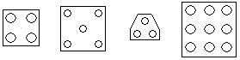

Reinforcement parameters and type
- Reinforcement shape - The shape displayed depends on a selected reinforcement type):
- Bars: - Bar Grade and Diameter.
- Material - Steel Grade for reinforcement.
- Hooks - Choose from None, 135 degrees, 90 degrees, 135 degrees seismic & 90 degrees seismic.
- sk = Centre to centre spacing.
- lk = Leg length.

User Reinforcement
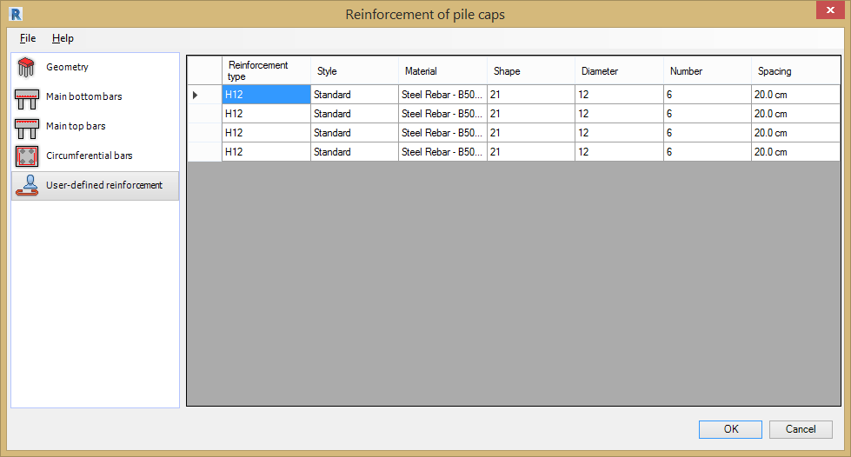
The User-defined dialog is displayed when a beam is selected that already contains reinforcement placed using the Revit® rebar tools.
The table displays information for the reinforcing bars already placed inside the beam:
- Reinforcement type - Bar Grade and Diameter.
- Style - Bar type, bent, straight or stirrup.
- Material - Steel Grade for reinforcement.
- Bar shape - Shape Code number.
- Bar diameter - Diameter of bar.
- Number - Number of bars.
- Spacing - Centre to centre spacing between bars.
The data in this table is displayed according to the rules used in Autodesk® Revit®.

Piles

General Information
The Pile Reinforcement Tool generates the reinforcement for a pile that has been defined in a Revit® model. Reinforcement can be generated for the pile arrangements shown in drawing below:
- A single pile.
- A group of piles positioned under the pile cap.
If there are at least 2 piles under the pile cap, the Pile Reinforcement Tool generates the same reinforcement for each pile.
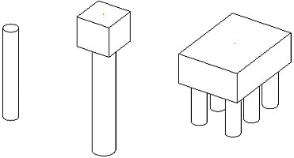

Note: The current version of the Pile Reinforcement Tool generates reinforcement for RC piles with a round cross-section.
The Extension reads the necessary information for a selected pile (selected piles) or a pile cap from Revit®:
- Pile geometry.
- Parameters of shape families.
- Parameters of reinforcing bars (diameter + material).
- Parameters of hooks for reinforcing bars.
Important: The Pile Reinforcement Tool will not launch if:
- The selected piles are of different geometry.
- The selected a pile cap has piles that are of different geometry.
Define the reinforcement parameters for the Pile Reinforcement Tool by selecting the options from the File Pull Down Menu;
- Open - Opens a file with saved reinforcement parameters.
- Save / Save As - Saves parameters to an external file. Use this file to generate reinforcement for a pile with the same geometry.
- Regional Settings - see chapter 2 for details.
- Close - closes the Pile Reinforcement Tool.

Pile Reinforcement Dialog
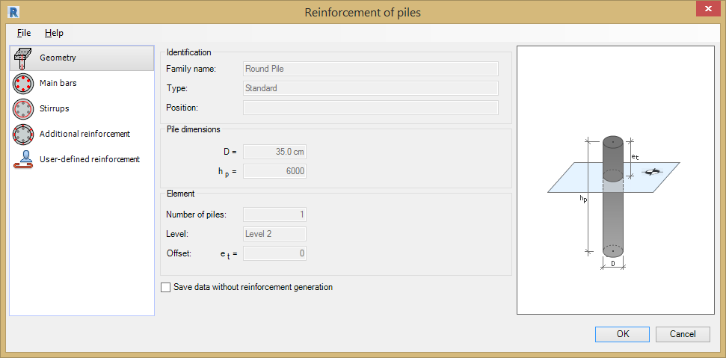
The dialog for generating pile reinforcement has the following parts:
- Left panel - options to select a component of the pile reinforcement definition:
- Geometry.
- Main Bars.
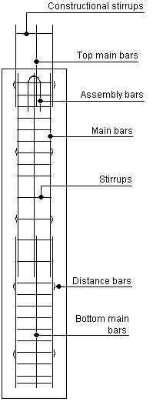
- Stirrups.
- Additional Reinforcement.
- User Reinforcement.
- In the middle - an area to define parameters of a pile and its reinforcement (depending on a selected component).
- Right panel - a view of the defined pile and the pile reinforcement you are generating.

Generating the Pile Reinforcement

Geometry
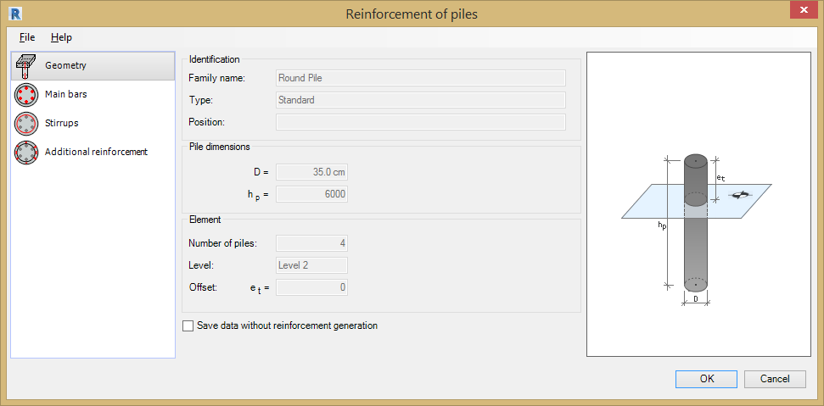
The Pile Section Geometry parameters are displayed in the geometry tab, these are laoded from the Revit® model:
- Identification - Displays the Family Name and Family Type.
- Pile Dimensions - Displays the pile length hp and pile diameter D.
- Element - Displays the number of piles, the Revit® Level and the offset (et) of the pile above or below the Revit® Level.
If the Save data without reinforcement generation option is cleared, the reinforcing bars are generated and displayed in Autodesk® Revit®. If this option is selected, the reinforcement data is generated (and can be used after restarting the Extension), but reinforcing bars cannot be displayed in Autodesk® Revit®.

Main Bars
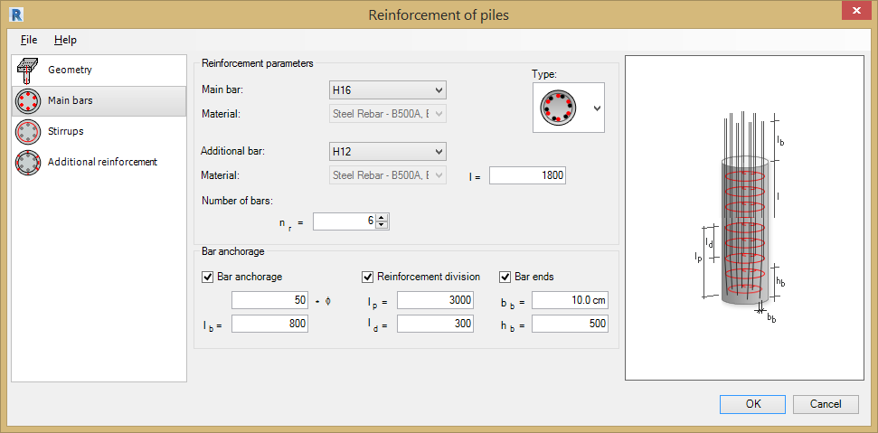
Define the following parameters for the Main Bars:
Reinforcement Parameters
- Main Bar - Select the bar diameter.
- Material - Steel Grade for reinforcement.
- Type - Select the type of distribution of bars from the drop down menu:
- 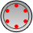- Only main bars.
- 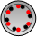 - Top bars next to main bars.
- 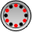 - Top bars between main bars.
Additional Reinforcing Bars Parameters
- Additional Bar - Select the bar diameter.
- Material - Steel Grade for reinforcement.
- l = Reinforcing bar length.
- nr = Number of main reinforcing bars (and additional bars, if necessary) along the pile circumference.
Bar Anchorage Parameters
- Bar Anchorage - Tick the option to add bar anchorage (in the top part of the pile).
- Anchorage length *dia - Type in the number of bar diameters the bar projects above the pile.
- lb = Enter the distance the bar projects above the pile.
- Reinforcement division - Tick this option to sub-divide the main rebars along the pile
- lp = Total length of lower rebar.
- ld = Lap distance.
- Bar Ends - Tick this option to bend the bottom rebar.
- bb = Horizontal distance for rebar taper.
- hb = Vertical distance for rebar taper.

Stirrups
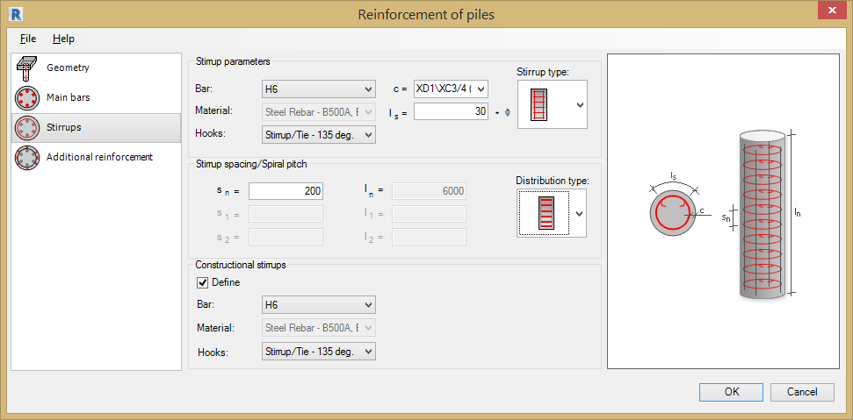
Define the following parameters for the Stirrups in the Pile.
Stirrup Parameters
- stirrup type - Choose the stirrup type from the drop down menu.
- Bar - Type & diameter.
- Material - Steel Grade for reinforcement.
- Hook 1 - Choose from None, 135 degrees, 90 degrees, 135 degrees seismic & 90 degrees seismic.
- c = Cover value.
- ls = Lap value.
Stirrup spacing/Spiral pitch
- Distribution type - Choose the stirrup distribution from the drop down menu.
- One stirrup zone along the pile length.
- Two stirrup zones along the pile length.
- Three stirrup zones along the pile length.
The fields will vary depending on the stirrup distribution type.
- s1 = Spacing of top links.
- l1 = Height of range of top links.
- sn = Spacing of middle links.
- ln = Height of range of middle links.
- s2 = Spacing of bottom links.
- l2 = Height of range of bottom links.
Spiral pitch
- s = Pitch of spiral bar.
- l = Total height of spiral bar.
- s1 = Number of bar diameters.
Constructional stirrups
- Define - Tick to add constructional stirrups to the pile. The Pile Reinforcement tool adds the following;
A stirrup in the top part of the pile, if the Bar anchorage option is selected.
A stirrup in the bottom part of the pile, if the Bar ends option is selected.
- Bar - Type & diameter.
- Material - Steel Grade for reinforcement.
- Hook 1 - Choose from None, 135 degrees, 90 degrees, 135 degrees seismic & 90 degrees seismic.

Additional Reinforcement
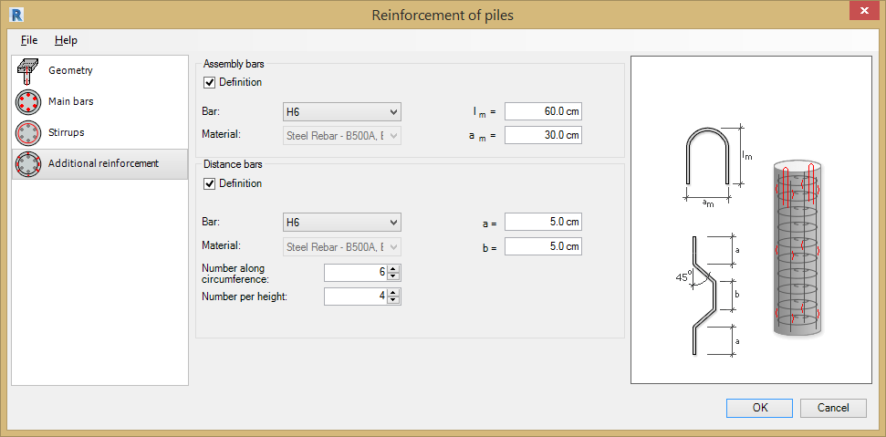
Use this tab to define additional pile reinforcement; assembly and/or distance bars.
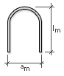
Assembly Bars
- Definition - Tick to add assembly bars to the pile.
- Bar - Type & diameter.
- Material - Steel Grade for reinforcement.
- lm - Type in leg dimension.
- am - Type in leg dimension.
Distance Bars
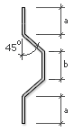
- Definition - Tick to add distance bars to the pile.
- Bar - Type & diameter.
- Material - Steel Grade for reinforcement.
- Number along circumference - Type in number required.
- Number per height - Type in number required.
- a= Type in leg a dimension.
- b = Type in leg b dimension.

User Reinforcement
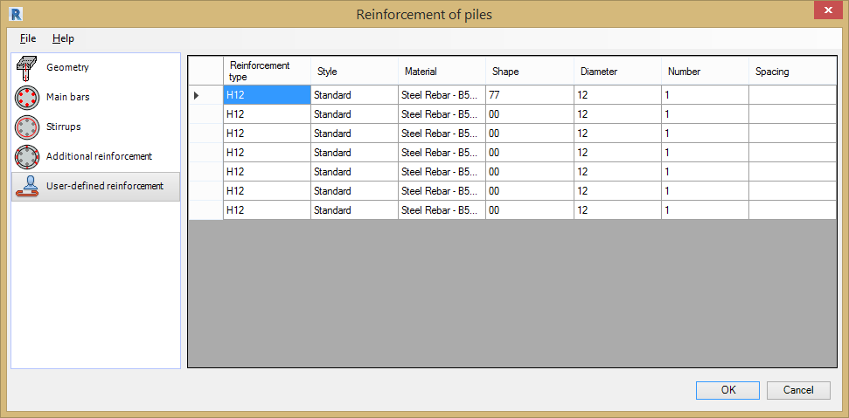
The User-defined dialog is displayed when a pile is selected that already contains reinforcement placed using the Revit® rebar tools.
The table displays information for the reinforcing bars already placed inside the beam:
- Reinforcement type - Bar Grade and Diameter.
- Style - Bar type, bent, straight or stirrup.
- Material - Steel Grade for reinforcement.
- Bar shape - Shape Code number.
- Bar diameter - Diameter of bar.
- Number - Number of bars.
- Spacing - Centre to centre spacing between bars.
The data in this table is displayed according to the rules used in Autodesk® Revit®.

Retaining Walls

General Information
The Retaining Wall Reinforcement Tool generates reinforcement for a retaining wall in a Revit® model. Reinforcement can be generated for the following types of retaining wall section in Revit®:
- Structure foundations in the shape of a typical retaining wall.
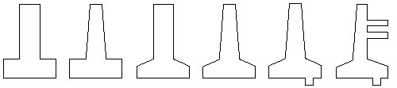
- Foundations under walls of shapes as shown in the image (wall + foundation).
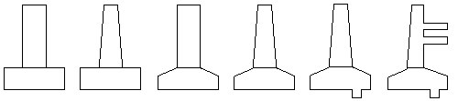
The current version of the Retaining Wall Reinforcement tool can add reinforcement to rectilinear retaining walls of the following shapes:
- Straight.
- With walls of varying thickness.
- With the inclined wall.
- With the inclined footing.
Reinforcement can only be generated for retaining walls with a constant cross-section along the retaining wall length; a retaining wall cannot be inclined toward the XY plane.
You can load retaining wall information from Revit®:
- Geometry of the wall and footing of the retaining wall.
- Parameters of reinforcing bars (diameter + material).
- Parameters of hooks for reinforcing bars.
Define the reinforcement parameters for the Retaining Wall Reinforcement Tool by selecting the options from the File Pull Down Menu;
- Open - Opens a file with saved reinforcement parameters.
- Save / Save As - Saves parameters to an external file. Use this file to generate reinforcement for a retaining wall with the same geometry.
- Regional Settings - See chapter 2 for details.
- Close - Closes the Retaining Wall Reinforcement Tool.

Retaining Wall Reinforcement Dialog
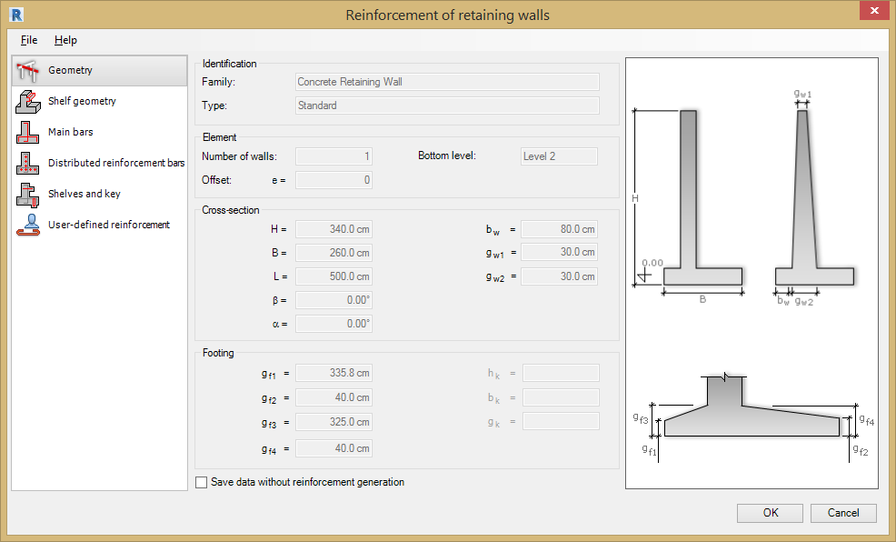
The dialog box for generation of retaining wall reinforcement has 3 main parts:
- On the left are options for selecting a component used to define the retaining wall reinforcement:
- - Geometry.
- - Shelf Geometry.
- - Main Bars.
- - Distributed Reinforcement.
- - Shelves and Key Reinforcement.
- - User Reinforcement.
- In the centre, define parameters of the retaining wall and reinforcement (depending on a selected component).
- On the right is a graphical view of a defined retaining wall and generated retaining wall reinforcement.

Generating Retaining Wall Reinforcement

Geometry
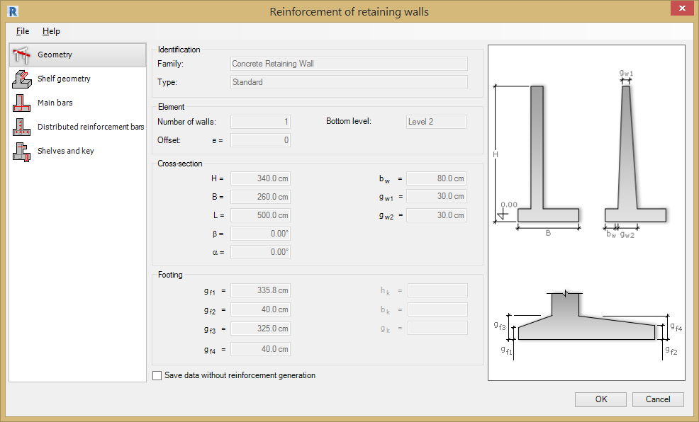
The information displayed in the Geometry tab is loaded from the retaining wall that has been modelled in Revit®:
- Identification parameters - Of a retaining wall loaded from a Revit® model.
- Number of retaining walls and the bottom level.
- Dimensions of the cross-section of the wall.
- Dimensions of the cross-section of the footing.
The number of dimensions depends on the selected retaining wall type.
If the Save data without reinforcement generation option is cleared, the reinforcing bars are generated and displayed in Autodesk® Revit®. If this option is selected, the reinforcement data is generated (and can be used after restarting the Extension), but reinforcing bars cannot be displayed in Autodesk® Revit®.

Shelf Geometry
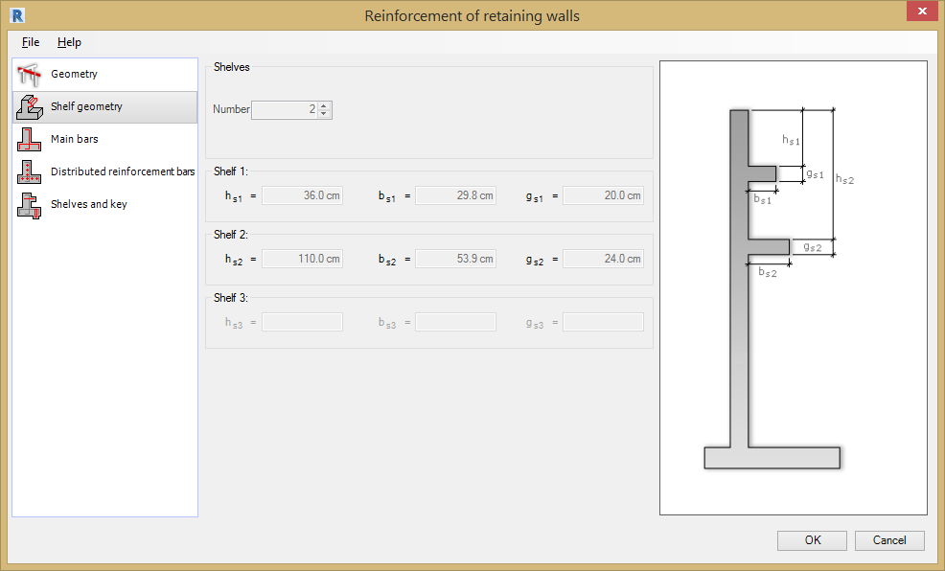
The information displayed in the Shelf Geometry tab is loaded from the retaining wall that has been modelled in Revit®:
- Number of shelves - Cannot exceed 3 shelves.
- Dimensions of shelves.
- The number of dimensions - Depends on the number of shelves.

Main Bars
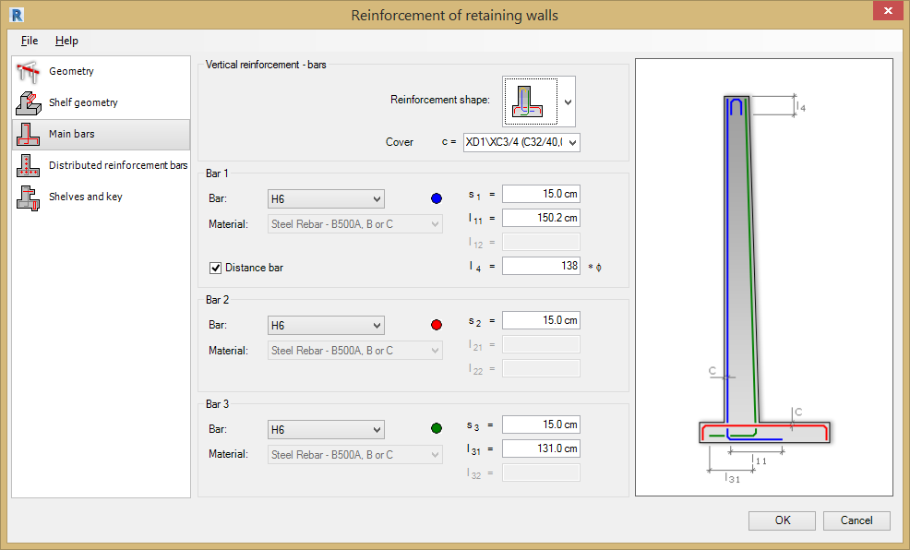
Define the following parameters for the Main Bars in this tab:
- Reinforcement shape:
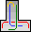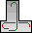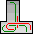
- c = Cover value.
Main reinforcing bars parameters: (Note: each main bar 1 to 3 is represented in the diagram on the right using a colour.)
- Bar - Select the bar diameter.
- Material: - Steel Grade for reinforcement.
- s* = Bar spacing.
- l* = Length of bars.
- Distance bar = Tick this option to add bar anchors.
The Distance bar option is available for the first type of reinforcement. If selected, it generates additional reinforcing bars in the top part of the retaining wall (as shown in the image above). The length is specified in the field next to the option l4.

Distributed Reinforcement
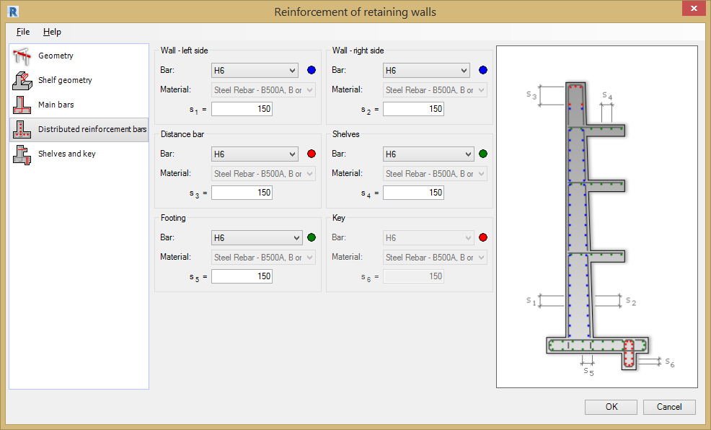
Define the following parameters for the distributed reinforcement bars in this tab:
Note: Each distribution bar is represented in the diagram on the right using a colour).
The dialog is divide into sections to define the following;
- Wall Left Side - Diameter, material and spacing.
- Wall Right Side - Diameter, material and spacing.
- Distance Bar - Diameter, material and spacing.
- Shelves - Diameter, material and spacing.
- Footing - Diameter, material and spacing.
- Key - Diameter, material and spacing.

Shelf and Key Reinforcement
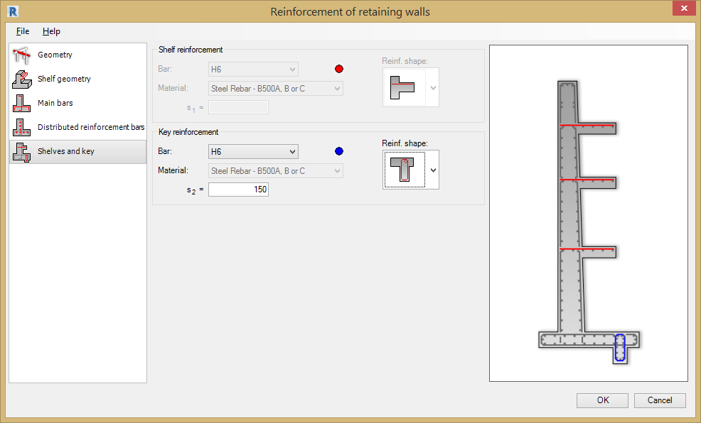
Define the following parameters for the shelf reinforcement in this tab:
Shelf reinforcement:
- Reinforcement shape:
- Bar - Select the bar diameter.
- Material - Steel Grade for reinforcement.
- s* = Bar spacing.
Key reinforcement:
- Reinforcement shape:
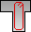
- Bar - Select the bar diameter.
- Material - Steel Grade for reinforcement.
- s* = Bar spacing.

User Reinforcement
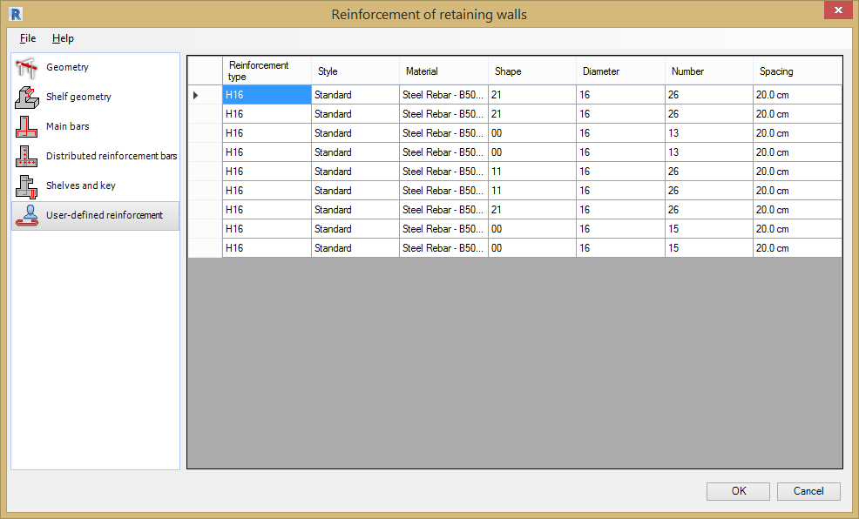
The User-defined dialog is displayed when a retaining wall is selected that already contains reinforcement placed using the Revit® rebar tools.
The table displays information for the reinforcing bars already placed inside the beam:
- Reinforcement type - Bar Grade and Diameter.
- Style - Bar type, bent, straight or stirrup.
- Material - Steel Grade for reinforcement.
- Bar shape - Shape Code number.
- Bar diameter - Diameter of bar.
- Number - Number of bars.
- Spacing - Centre to centre spacing between bars.
The data in this table is displayed according to the rules used in Autodesk® Revit®.

Slab Corners

General Information
The Slab Corner Reinforcement Tool generates reinforcement for the corners of RC slabs in a Revit® model.
The following slab corner information from Revit® is loaded into the tool:
- Slab geometry.
- Reinforcing bars parameters (diameter + material).
- Hook parameters for reinforcing bars.
The Slab Corner reinforcement tool will not start, if:
- No objects have been selected.
- Any object other than a concrete slab has been selected.
- Selected slabs have different geometries.
- The selected slab does not have slab corners between 45 and 135 degrees.
- The concrete slab does not have a structural load bearing layer.
- The Structural slab property is not active.
- The selected slab is sloping.
In the Slab Corner Tool it is assumed that for each corner the x axis is on the right side of the corner angle bisector and the y axis is on the left side of the bisector (as shown in the image).
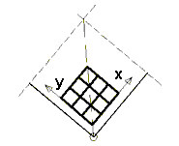
Define the reinforcement parameters for the Slab Corners Reinforcement Tool by selecting the options from the File Pull Down Menu;
- Open - Opens a file with saved reinforcement parameters.
- Save / Save As - Saves parameters to an external file. Use this file to generate reinforcement for a slab corner with the same geometry.
- Regional Settings - see chapter 2 for details.
- Close - closes the Slab Corner Reinforcement Tool.

Slab Corner Reinforcement Dialog
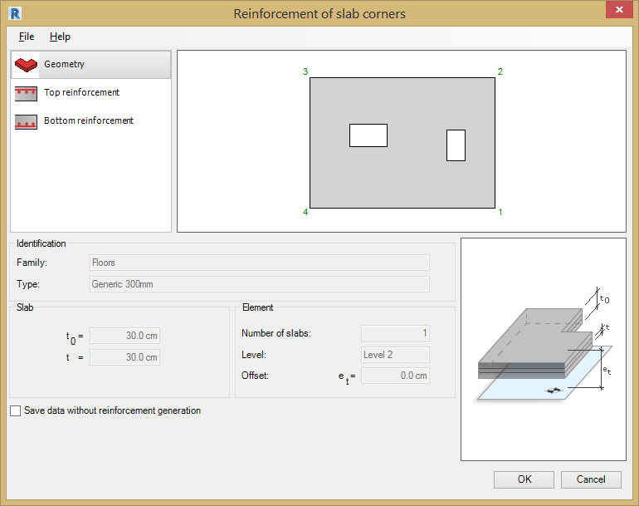
The dialog for generating reinforcement of slab corners is divided into 4 main parts:
- Top left hand corner are the options for selecting a component used to define the slab corner reinforcement:
- - Geometry.
- - Top reinforcement.
- - Bottom reinforcement.
- - User Reinforcement.
- Top right hand side is a preview of a slab contour with numbered slab corners.
- Bottom left hand side is an area to define parameters of reinforcement of slab corners (depending on a selected component).
- Bottom right hand side is a diagram of the defined slab corner and the generated corner reinforcement.

Generating the Slab Corner Reinforcement

Geometry
The information displayed in the Geometry tab is loaded from the concrete slab that has been modelled & selected in Revit®:
- Identification parameters - Family and type of a slab loaded from a Revit® model.
- Slab thickness t 0 and thickness of a load-carrying layer t.
- Number of slabs, level and offset e T.
If the Save data without reinforcement generation option is cleared, the reinforcing bars are generated and displayed in Autodesk® Revit®. If this option is selected, the reinforcement data is generated (and can be used after restarting the Extension), but reinforcing bars cannot be displayed in Autodesk® Revit®.

Top Reinforcement
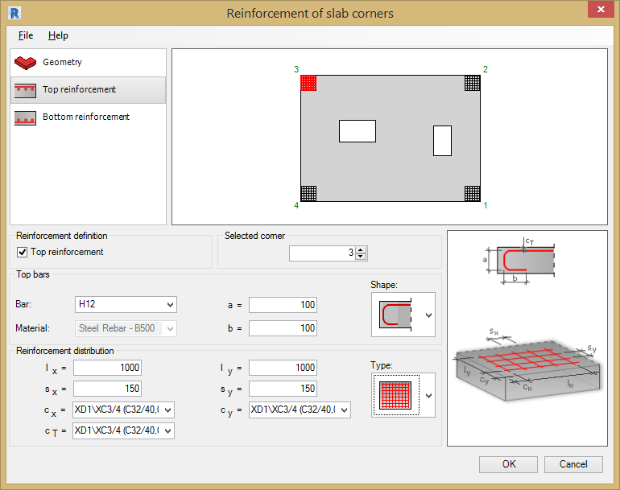
Define the following parameters for the Top Bars in this tab:
- Top Reinforcement - Tick this option to add reinforcement to the top face of the slab.
- Selected Corner - Use the Selected Corner option to choose the slab corner to add the reinforcement.
Top reinforcement bars parameters:
Definition of reinforcement for a selected corner:
- Reinforcement shape - Select the required bar shape.
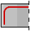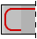
- Bar - Select the bar diameter.
- Material: - Steel Grade for reinforcement.
- a = Length of bars.
- b = Length of bars.
Reinforcement Distribution Parameters:
- Reinforcement type - select the required distribution type
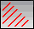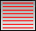
- lx = Length of mat.
- ly = Width of mat.
- sx = Centre to centre spacing.
- sy = Centre to centre spacing.
- cx = Cover left and right.
- cy = Cover top and bottom.
- cT - Cover top.

Bottom Reinforcement
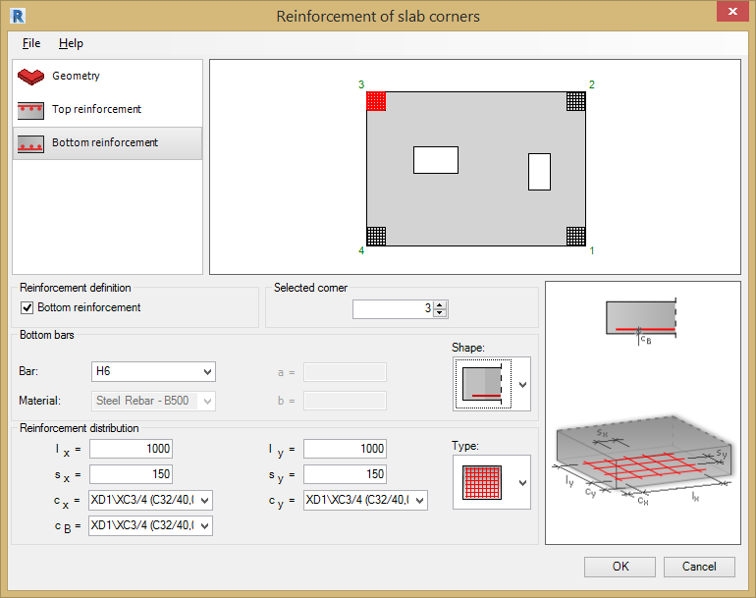
Define the following parameters for the Bottom Bars in this tab:
- Bottom Reinforcement - Tick this option to add reinforcement to the bottom face of the slab.
- Selected Corner - Use the Selected Corner option to choose the slab corner to add the reinforcement.
Bottom reinforcement bar parameters:
Definition of reinforcement for a selected corner:
- Reinforcement Shape - Select the required bar shape.
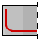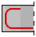
- Bar - Select the bar diameter.
- Material - Steel Grade for reinforcement.
- a = Length of bars.
- b = Length of bars.
Reinforcement Distribution Parameters:
- Reinforcement Type - select the required distribution type.
- lx = Length of mat.
- ly = Width of mat.
- sx = Centre to centre spacing.
- sy = Centre to centre spacing.
- cx = Cover left and right.
- cy = Cover top and bottom.

User Reinforcement
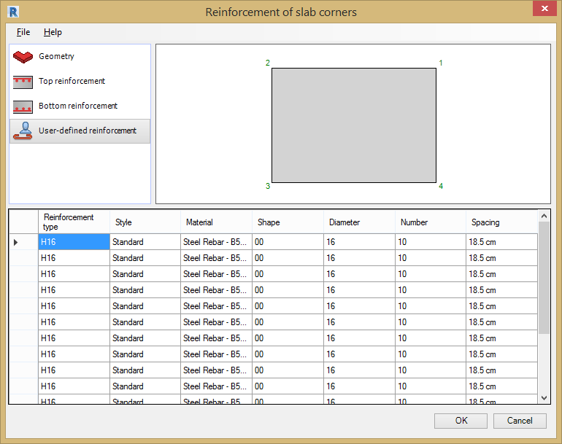
The User-defined dialog is displayed when a slab corner is selected that already contains reinforcement placed using the Revit® rebar tools.
The table displays information for the reinforcing bars already placed inside the beam:
- Reinforcement type - Bar Grade and Diameter.
- Style - Bar type, bent, straight or stirrup.
- Material - Steel Grade for reinforcement.
- Bar shape - Shape Code number.
- Bar diameter - Diameter of bar.
- Number - Number of bars.
- Spacing - Centre to centre spacing between bars.
The data in this table is displayed according to the rules used in Autodesk® Revit®.

Slab Openings

General Information
The Slab Openings Reinforcement Tool generates reinforcement around an opening in concrete slab. The opening in the slab needs to be created individually with the Revit Opening Tools. This tool does not support openings created as part of the Revit Slab Creation Tool.
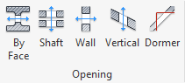
The Tool will generate Reinforcement for the following types of RC slab openings:
- Rectangular openings.
- Rectangular openings adjacent to one slab edge.
- Rectangular openings adjacent to two slab edges.
- Round openings.
Note Corner fillets in rectangular openings are disregarded (such openings are treated as rectangular).
You can load RC slab opening information from Revit:
- Geometry of a slab opening.
- Parameters (diameter and material) of reinforcing bars.
- Parameters of hooks for reinforcing bars.
Define the reinforcement parameters for the Slab Corners Reinforcement Tool by selecting the options from the File Pull Down Menu;
- Open - Opens a file with saved reinforcement parameters.
- Save / Save As - Saves parameters to an external file. Use this file to generate reinforcement for a slab corner with the same geometry.
- Regional Settings - see chapter 2 for details.
- Close - closes the Slab Corner Reinforcement Tool.

Slab Opening Reinforcement Dialog
The Reinforcement of slab opening dialog is divided into three main parts:
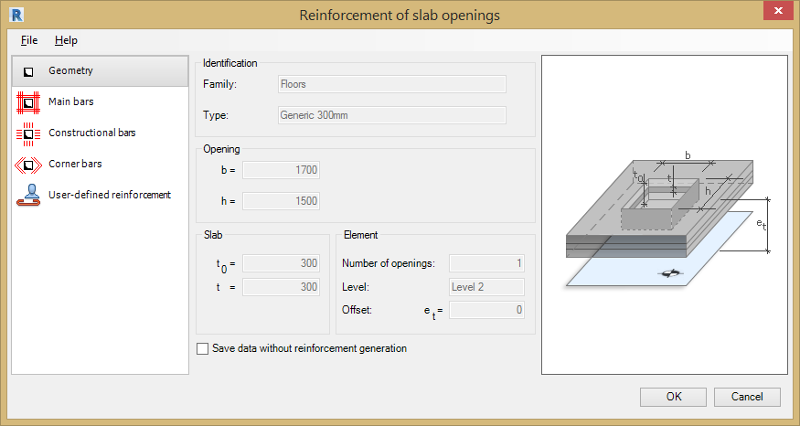
- On the left are options for selecting a component used to define the slab opening reinforcement:
- Geometry
- Main Bars
- Constructional Bars
- Corner Bars
- User-Defined Reinforcement
The reinforcement generated by the Slab Openings Tool are shown in the diagram below;
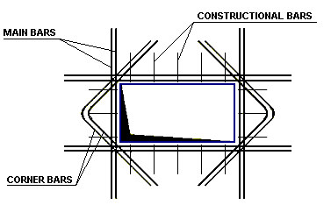
- In the centre, you can define parameters of the slab opening and reinforcement (depending on a selected component).
- On the right is a graphical view of a defined slab opening and the generated opening reinforcement.

Generating Slab Opening Reinforcement

Geometry
The information displayed in the Geometry tab is loaded from the opening in the concrete slab that has been modelled & selected in Revit®:
- Identification parameters (family and type) of an opening loaded from a Revit model.
- Opening dimensions.
- Slab thickness (for a layered slab, thickness of the structural layer).
- Element parameters, including number of openings, level, and offset.
Note: For an opening to be recognised correctly in the Extension, it has to be defined in Revit using the Opening > Opening by face option. Each opening in the slab must be defined separately.
Note: In the Revit Element Properties dialog, ensure that the Structural option is selected for the slab.
The Slab Openings Tool will add reinforcement to following opening shapes in an RC slab:
- Rectangular openings.
- Rectangular openings adjacent to one slab edge.
- Rectangular openings adjacent to two slab edges.
- Round openings.
If the Save data without reinforcement generation option is cleared, the reinforcing bars are generated and displayed in Autodesk® Revit®. If this option is selected, the reinforcement data is generated (and can be used after restarting the Extension), but reinforcing bars cannot be displayed in Autodesk® Revit®.

Main Bars
Define the following parameters for the Main Bars:
Bars
- Main Bar - Select the bar diameter.
- Material - Steel Grade for reinforcement.
- Number of bars in both directions (n b and n h )
Reinforcement parameters
Covers: select the required cover from the drop down menu.
- c - lateral cover, measured from the opening edge / vertical wall
- cb & ct - top and bottom cover.
Anchorage: enter the anchorage length as a multiple of bar diameters.
- lb – vertical anchorage.
- lh – horizontal anchorage.
Spacing: enter the spacing between reinforcement bar.
- sb – vertical spacing.
- sh – horizontal spacing.
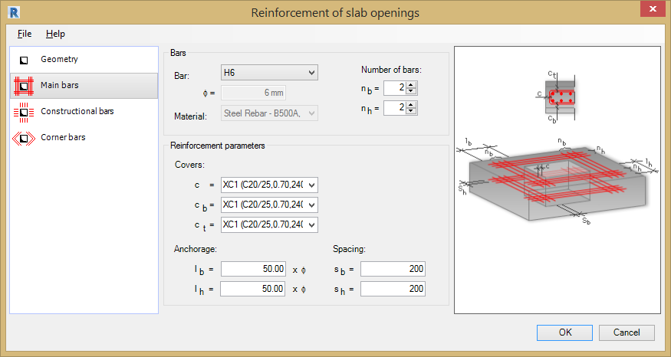
The bar parameters are loaded from the families defined in Revit. A bar diameter and material are associated with a selected steel grade (family).

Constructional Bars
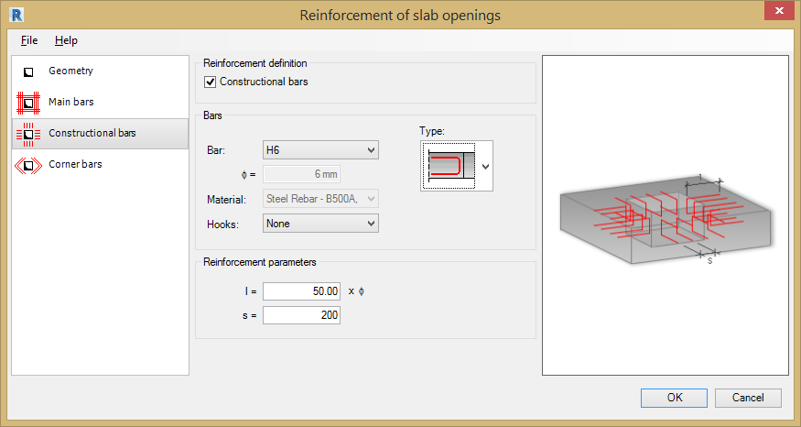
Reinforcement Definition
Tick the Constructional Bars option to at edge bars to the slab opening. The rebar will be placed perpendicular to the opening.
Bars
- Type: - select the required bar shape from the drop down menu.
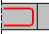 U-bar.
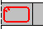 Stirrup / Link.
- Bars: - Bar Grade and Diameter.
- Material - Steel Grade for reinforcement.
- Hooks - Choose from None, 135 degrees, 90 degrees, 135 degrees seismic & 90 degrees seismic.
Reinforcement parameters
- s – type in the bar centre to centre distance.
- l - reinforcement length specified as multiple of bar diameters.
Parameters of hooks and bars are loaded from the families defined in Revit. A bar diameter and material are associated with a selected steel grade (family).

Corner Bars
Use the Corner bars option to add reinforcement diagonally to the opening. To activate this tab, tick the Corner Bars option. You can then define parameters of bar reinforcement (reinforcement strengthening the opening corner).
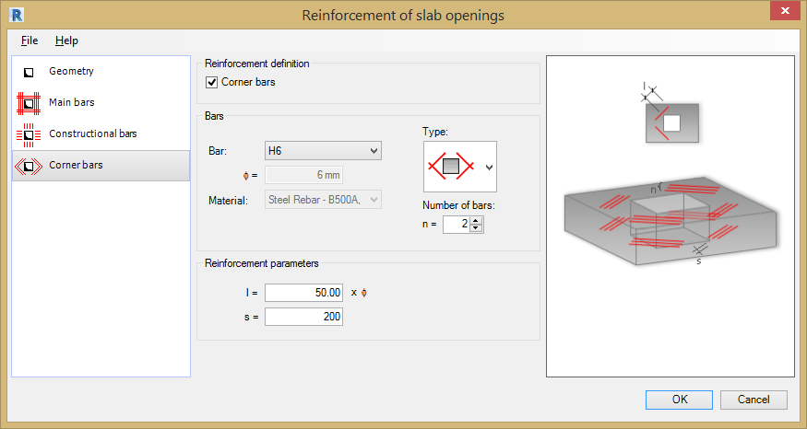
Bars
- Type: use the drop down menu to select the required corner bars.
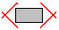Straight bars.
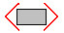L bars.
- Bars: - Bar Grade and Diameter.
- Material - Steel Grade for reinforcement.
- n- select the number of bars.
Reinforcement parameters
- s - Bar spacing.
- l – Reinforcement length specified as multiple of bar diameters.

User Reinforcement
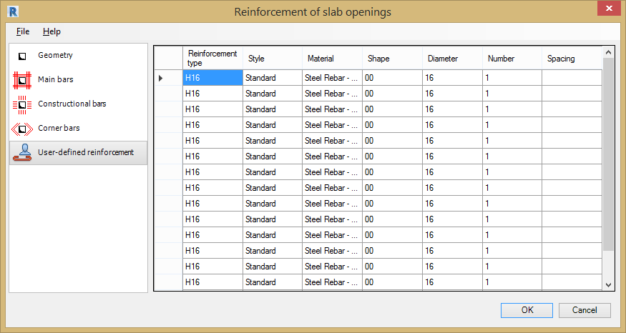
The User-defined dialog is displayed when a slab corner is selected that already contains reinforcement placed using the Revit® rebar tools.
The table displays information for the reinforcing bars already placed inside the beam:
- Reinforcement type - Bar Grade and Diameter.
- Style - Bar type, bent, straight or stirrup.
- Material - Steel Grade for reinforcement.
- Bar shape - Shape Code number.
- Bar diameter - Diameter of bar.
- Number - Number of bars.
- Spacing - Centre to centre spacing between bars.
The data in this table is displayed according to the rules used in Autodesk® Revit®.

Spread Footings

General Information
Use the Spread Footing Reinforcement Tool to generate the reinforcement for a spread footing in an Autodesk® Revit® / Autodesk® Robot Structural Analysis model. Reinforcement can be generated for the following types of footing cross-sections (and the adjoining column):
Spread footing
- Rectangular (simple and double).
- Trapezoidal.
Adjoining column
- RC rectangular.
- RC circular.
- Steel.
- No adjoining column.
You can load spread footing information from Autodesk® Revit®:
- Geometry of a spread footing.
- Geometry of the adjoining column.
- Parameters (diameter and material) of reinforcing bars.
- Parameters of hooks for reinforcing bars.
Define the reinforcement parameters for the Spread Footing Reinforcement Tool by selecting the options from the File Pull Down Menu;
- Open - Opens a file with saved reinforcement parameters.
- Save / Save As - Saves parameters to an external file. Use this file to generate reinforcement for a spread footing with the same geometry.
- Regional Settings - See chapter 2 for details.
- Close - Closes the Spread Footing Reinforcement Tool.

Spread Footing Reinforcement Dialog
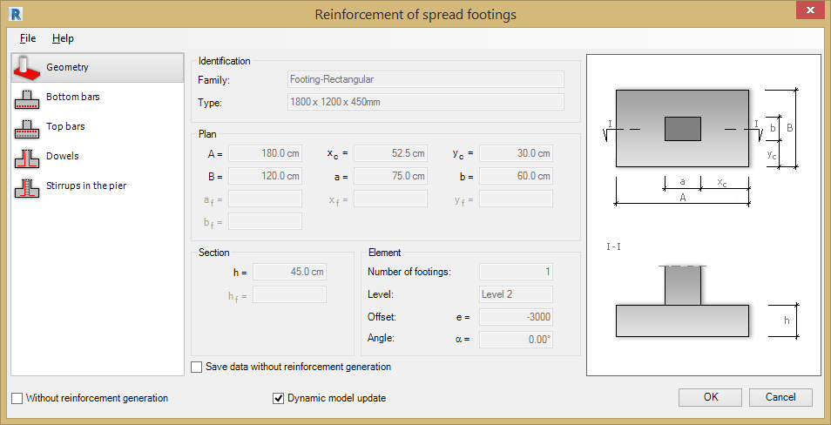
The dialog for generation of spread footing reinforcement has 3 main parts:
- On the left are options for selecting a component used to define spread footing reinforcement:
- - Geometry.
- - Bottom Bars.
- - Top Bars.
- - Dowels.
- - Stirrups in the pier.
- - User Reinforcement.
- In the centre, you can define parameters of the spread footing and reinforcement (determined by a selected component).
- On the right is a graphical view of a defined spread footing and the generated footing reinforcement.
In the lower part of the dialog box, two options are available:
- Without reinforcement generation - This option is available only in the case of parametric reinforcement that has not been generated (i.e. reinforcement defined by means of options in the extension tabs) and there is another type of reinforcement (e.g. pre-cast elements) in the RC element. If the option is activated, the parametric reinforcement is not generated; if the option is switched off, the parametric reinforcement is generated.
- Dynamic Model Update - This option, when selected, keeps the module data up-to-date with the Revit® model.
Changing the geometry of an adjoining element or elements starts the Spread Footing Tool and regenerates the reinforcement to include changes.
The option can be deselected for:
- A single element (after starting the Extension clear this option at the bottom of the dialog).
- All elements of a given type in a project, such as all beams (in the Extensions preferences).
- All types of elements (in the Extensions preferences).
The Dynamic Model Update is selected by default for the whole project and all supported elements.
When you open a file, created in version 2012 or lower, this option works as follows:
- It is deselected for existing elements that were reinforced using the Extension (this option can be selected when modifying reinforcement using this Extension).
- It is selected by default for new elements.
Note: This option is only available, if the module is launched in Revit®.

Generating the Spread Footing Reinforcement

Geometry
The Spread Footing Geometry includes:
- Identification parameters - Family and type of a spread footing loaded from a Revit® model.
- Plan dimensions.
- Section dimensions.
- Element parameters - including number of footings, level, offset, and angle.
The following shapes of spread footing and the column are supported:
Spread footing
  - Simple rectangle.
  - Double rectangle. 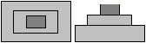
  - Trapezoid.
Adjoining column
- RC rectangular.
- RC circular.
- Steel.
- No adjoining column.
If the Save data without reinforcement generation option is cleared, the reinforcing bars are generated and displayed in Autodesk® Revit®. If this option is selected, the reinforcement data is generated (and can be used after restarting the Extension), but reinforcing bars cannot be displayed in Autodesk® Revit®.
Reinforcement of Spread Footings - launched from Autodesk® Robot Structural Analysis.
Specify the following data in the upper part of the dialog:
- Name of a spread footing.
- Number of defined spread footings.
- Spread footing dimensions - on plans and section dimensions.

Bottom Reinforcement
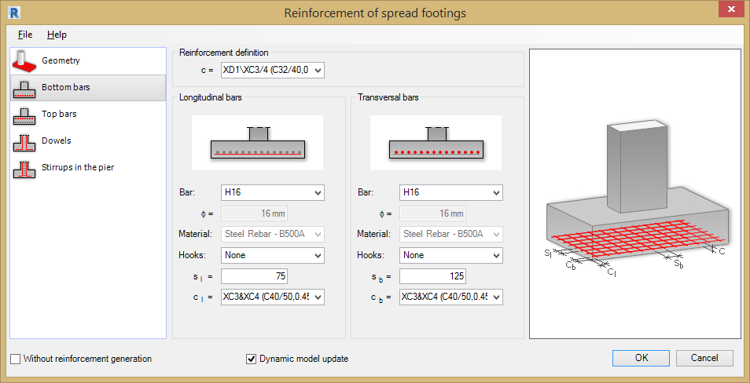
There are several parameters of bottom reinforcement defined in the Reinforcement of spread footing dialog:
Reinforcement Definition
- c = Cover value.
Longitudinal bars
- Bars: - Bar Grade and Diameter.
- Material - Steel Grade for reinforcement.
- Hooks - Choose from None, 135 degrees, 90 degrees, 135 degrees seismic & 90 degrees seismic.
- sl = Centre to centre spacing.
- c1 = Cover value.
Transversal bars
- Bars - Bar Grade and Diameter.
- Material - Steel Grade for reinforcement.
- Hooks - Choose from None, 135 degrees, 90 degrees, 135 degrees seismic & 90 degrees seismic.
- sb = Centre to centre spacing.
- cb = Cover value.
The hook and bar parameters are loaded from families defined in Revit®. The bar diameter and material are associated with a selected steel grade (family).

Top Reinforcement
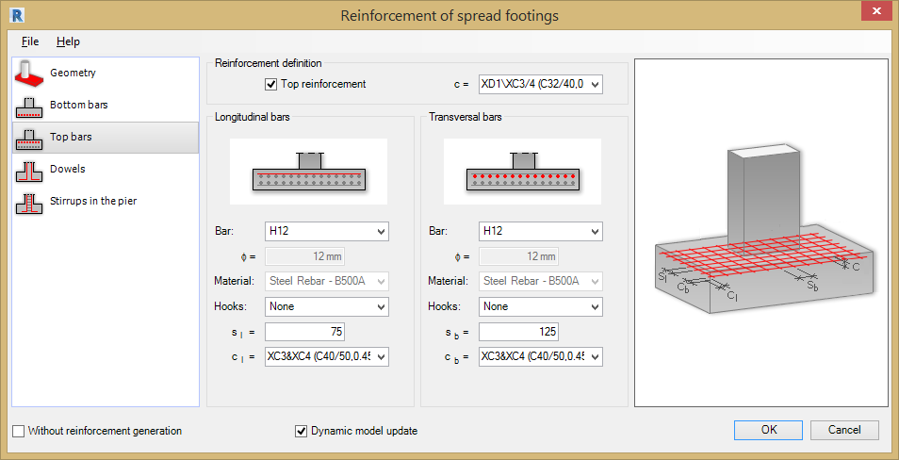
To generate top reinforcement in a spread footing, under Reinforcement definition, select Top reinforcement. You can then define parameters of top reinforcement:
Reinforcement definition
- Top reinforcement - Tick this option to add top reinforcement to the footing.
- c = Cover value.
Longitudinal bars
- Bars: - Bar Grade and Diameter.
- Material - Steel Grade for reinforcement.
- Hooks - Choose from None, 135 degrees, 90 degrees, 135 degrees seismic & 90 degrees seismic.
- sl = Centre to centre spacing.
- cl = Cover value.
Transversal bars
- Bars - Bar Grade and Diameter.
- Material - Steel Grade for reinforcement.
- Hooks - Choose from None, 135 degrees, 90 degrees, 135 degrees seismic & 90 degrees seismic.
- sb = Centre to centre spacing.
- cb = Cover value.
The hook and bar parameters are loaded from families defined in Revit®. The bar diameter and material are associated with a selected steel grade (family).

Dowels
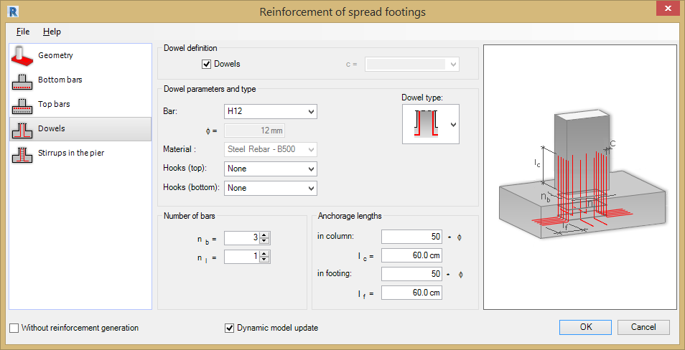
To generate dowel reinforcement in a spread footing, under Dowel definition, select Dowels. You can then define parameters of dowel reinforcement:
Dowel definition
- Dowels - Tick this option to add dowels to the spread footing.
- c = Cover value, the value will depend on the stirrup type selected.
Dowel parameters and type
- Dowel type for a rectangular cross-section – Select from the drop down menu.
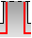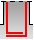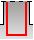
- Dowel type for a circular cross-section – Select from the drop down menu.
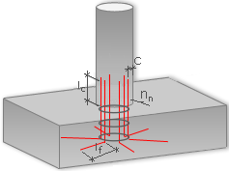
- Bars - Bar Grade and Diameter.
- Material - Steel Grade for reinforcement.
- Hooks (top) - Choose from None, 135 degrees, 90 degrees, 135 degrees seismic & 90 degrees seismic.
- Hooks (bottom) - Choose from None, 135 degrees, 90 degrees, 135 degrees seismic & 90 degrees seismic.
Number of bars
Adjoining column of a rectangular cross-section.
- nb = Along the shorter side.
- nl = Along the longer side.
Adjoining column of a circular cross-section.
- nn = Number of bars for circumferential distribution.
Anchorage lengths (defined as multiples of a bar diameter or as absolute values).
- In column.
- ln spread footing.

Stirrups
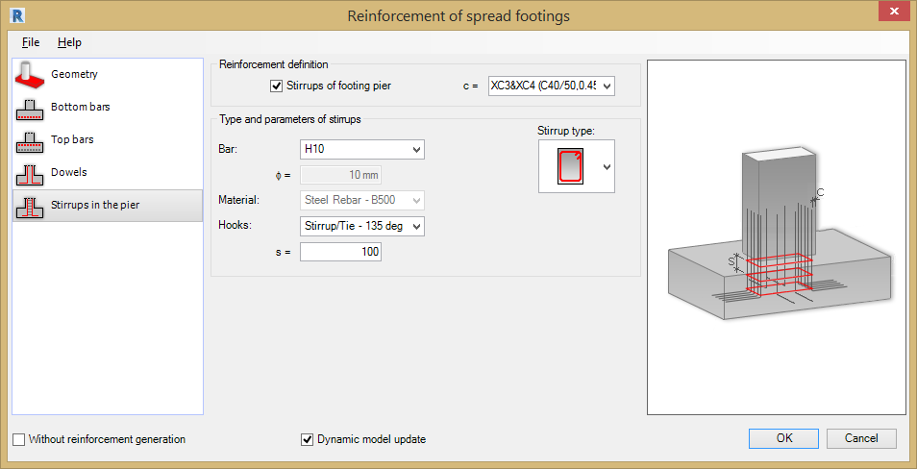
Define the following parameters for the Stirrups and the Spread Footing;
Reinforcement definition.
- Stirrups of footing pier - Switch this option on to add stirrups.
- c = Cover value c.
Type and parameters of stirrups.
- Dowel type for rectangular columns - Select the stirrup required from the drop down menu.
- Dowel type for circular columns - Select the stirrup required from the drop down menu.
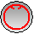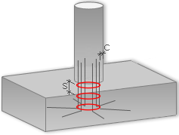
Note: It is not possible to define a footing under a circular column in Robot, this means that a circular stirrup cannot be created.
- Bars: - Bar Grade and Diameter.
- Material - Steel Grade for reinforcement.
- Hooks - Choose from None, 135 degrees, 90 degrees, 135 degrees seismic & 90 degrees seismic.
- s = Bar spacing.
Parameters of hooks and bars are loaded from families defined in Revit®. A bar diameter and material are associated with a selected steel grade (family).

User Reinforcement
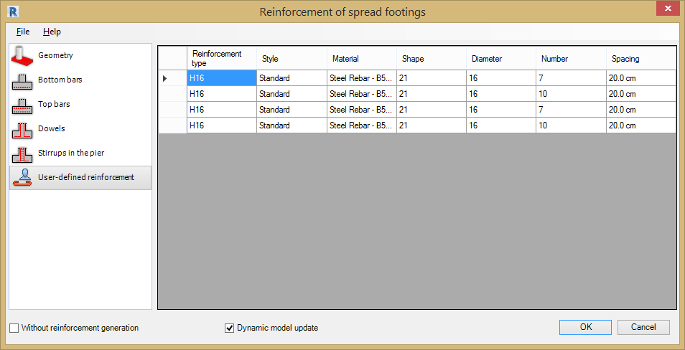
The User-defined dialog is displayed when a spread footing is selected that already contains reinforcement placed using the Revit® rebar tools.
The table displays information for the reinforcing bars already placed inside the beam:
- Reinforcement type - Bar Grade and Diameter.
- Style - Bar type, bent, straight or stirrup.
- Material - Steel Grade for reinforcement.
- Bar shape - Shape Code number.
- Bar diameter - Diameter of bar.
- Number - Number of bars.
- Spacing - Centre to centre spacing between bars.
The data in this table is displayed according to the rules used in Autodesk® Revit®.

Wall Corners

General Information
Use the Wall Corner Tool to generate the reinforcement for the corners and intersections of RC walls defined in a Revit® model. The following types of wall corner are supported:
- Wall corners (L shaped connection).
- Connection of walls (T-shaped connection).
- Intersection of 2 walls (X shaped connection).
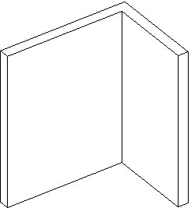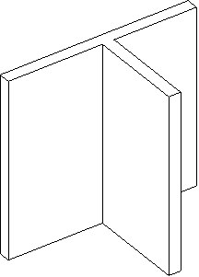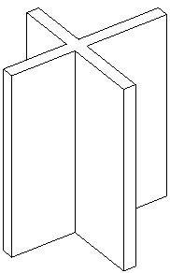
The following information is loaded from Revit® for the selected wall:
- Wall geometry.
- Reinforcing Bar parameters (diameter + material).
- Hook parameters for reinforcing bars.
Define the reinforcement parameters for the Wall Corners Reinforcement Tool by selecting the options from the File Pull Down Menu;
- Open - Opens a file with saved reinforcement parameters.
- Save / Save As - Saves parameters to an external file. Use this file to generate reinforcement for a wall corner with the same geometry.
- Regional Settings - See chapter 2 for details.
- Close - Closes the Wall Corners Reinforcement Tool.

Wall Corners Reinforcement Dialog
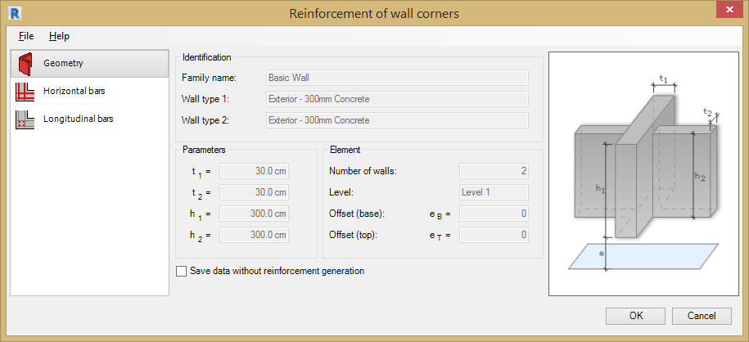
The Wall Corner Reinforcement dialog is divided into the following sections:
- Left panel - options to select a component of the definition of wall corner reinforcement:
- - Geometry.
- - Horizontal Bars (these are always generated).
- - Longitudinal Bars (these are optional).
- - User Reinforcement.
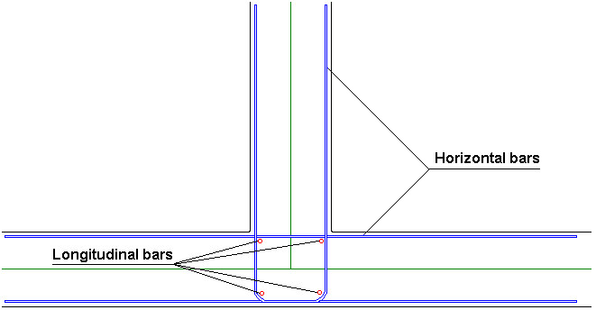
- In the middle - An area to define parameters of reinforcement of wall corners (depending on a selected component).
- Right panel - A view of the defined wall corner and the reinforcement of corners you are generating.

Generating Wall Corner Reinforcement

Geometry
The parameters of the RC wall corner geometry includes:
- Identification - The parameters identifying a wall (family name, wall types): loaded from a Revit® model.
- Parameters - The wall thicknesses (t 1 and t 2 ) and wall height h.
- Element - The number of walls, level and offsets e B and e T (base and top).
If the Save data without reinforcement generation option is cleared, the reinforcing bars are generated and displayed in Autodesk® Revit®. If this option is selected, the reinforcement data is generated (and can be used after restarting the Extension), but reinforcing bars cannot be displayed in Autodesk® Revit®.

Horizontal Bars
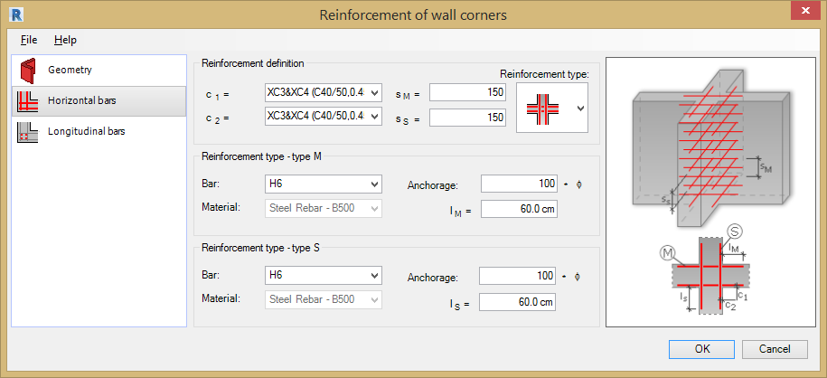
Define the horizontal bar parameters in this tab:
Reinforcement definition:
- Reinforcement type: - Choose the required reinforcement layout from the drop down menu. The intersection type selected in the Revit® model determines which layouts are displayed.
L Type Intersection.
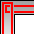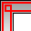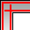
T Type Intersection.
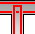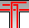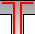
X Type Intersection.
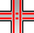
- c1 = Cover (for the first wall).
- c2 = Cover (for the second wall).
- s = Bar spacing.
Reinforcement type – type M:
- Bars - Bar Grade and Diameter.
- Material - Steel Grade for reinforcement.
- Anchorage - Specify the anchorage as multiples of the bar diameter
- lM = Anchorage length.
Reinforcement type – type S:
- Bars - Bar Grade and Diameter.
- Material - Steel Grade for reinforcement.
- Anchorage - Specify the anchorage as multiples of the bar diameter.
- lS = Anchorage length.
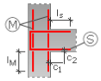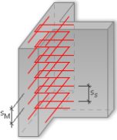
The anchorage lengths lM and lS are not available for all the reinforcement types. The selected type of intersection determines which anchorage fields are available.
Parameters of bars are loaded from families defined in Revit®. A bar diameter and a material are associated with a selected steel grade (family).

Longitudinal Bars
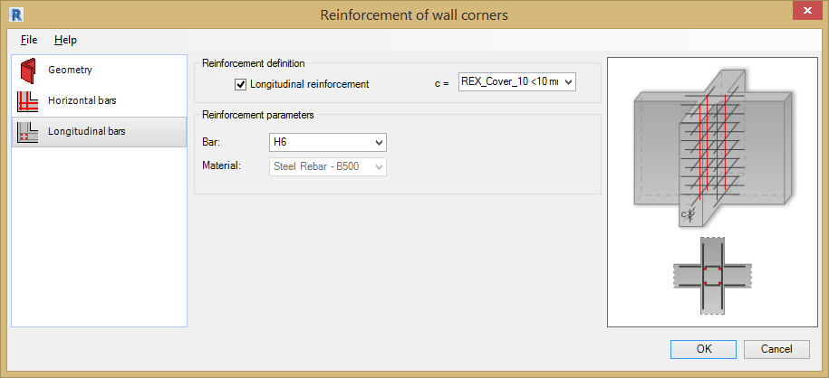
Switch on and define the Longitudinal Bar parameters using this tab:
Note: If you turn on the Longitudinal reinforcement option, the Extension always generates 4 reinforcing bars which are positioned where horizontal bars bend or intersect.
Reinforcement definition.
- Longitudinal reinforcement - Tick this option to add longitudinal reinforcement.
- c = Cover (top and bottom side).
Reinforcement Parameters
- Bars - Bar Grade and Diameter.
- Material - Steel Grade for reinforcement.
Parameters of bars are loaded from families defined in Revit®. A bar diameter and a material are associated with a selected steel grade (family).

User Reinforcement
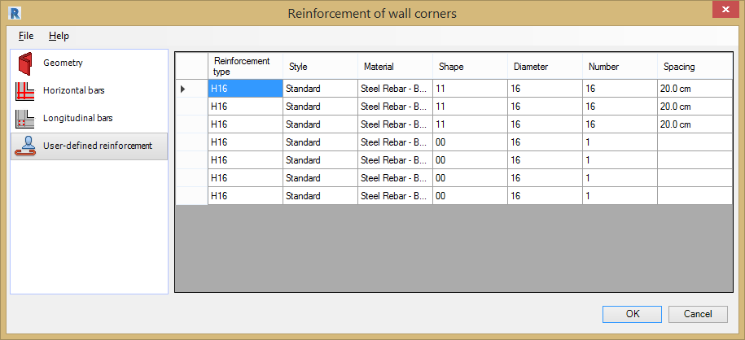
The User-defined dialog is displayed when a wall corner is selected that already contains reinforcement placed using the Revit® rebar tools.
The table displays information for the reinforcing bars already placed inside the beam:
- Reinforcement type - Bar Grade and Diameter
- Style - Bar type, bent, straight or stirrup
- Material - Steel Grade for reinforcement
- Bar shape - Shape Code number
- Bar diameter - Diameter of bar
- Number - Number of bars
- Spacing - Centre to centre spacing between bars
The data in this table is displayed according to the rules used in Autodesk® Revit®.

Walls

General Information
Use the Wall Reinforcement Tool to generate the reinforcing bars for an RC wall in a Revit® model.
The Tool only recognises rectilinear walls; it will not generate:
- Opening reinforcement (a reinforcement grid is only cut to fit the opening dimensions).
- Additional reinforcement at the intersection of walls and at adjoining walls.
The following wall information is loaded from Revit®:
- Geometry
- Reinforcing Bar Parameters (diameter and material)
- Hook Parameters for the reinforcing bars.
Note: If reinforcement is generated for walls adjoining at an angle, the wall geometry is recognised depending on the position of the neighbouring walls and the order in which they were drawn. It may be that the reinforcement of adjoining walls will not be entirely correct for the Extension standard settings.
To ensure that the reinforcement is distributed correctly, it is necessary to specify the following parameter values:
- Horizontal bars: cover c, dowels
- Vertical bars: parameters a l and a r .
Define the reinforcement parameters for the Wall Reinforcement Tool by selecting the options from the File Pull Down Menu;
- Open - Opens a file with saved reinforcement parameters.
- Save / Save As - Saves parameters to an external file. Use this file to generate reinforcement for a wall with the same geometry.
- Regional Settings - See chapter 2 for details
- Close - Closes the Wall Reinforcement Tool.

Wall Reinforcement Dialog
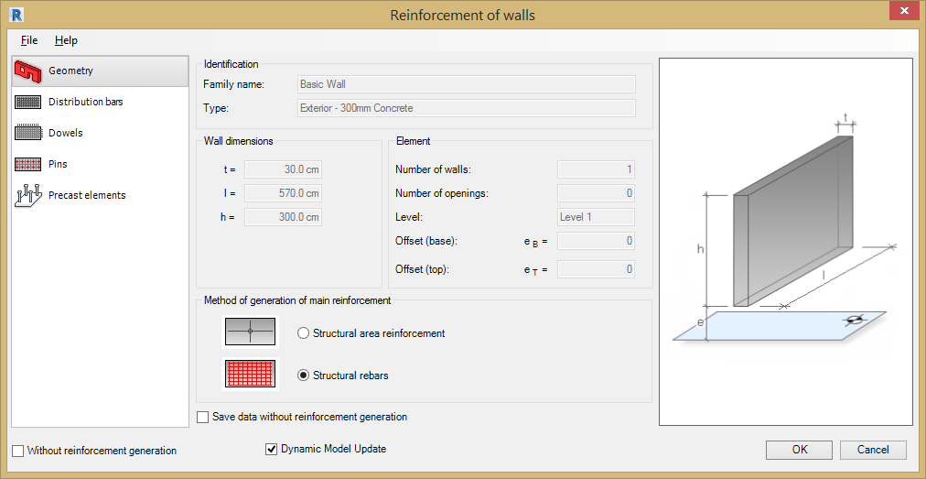

- On the left are options for selecting a component used to define wall reinforcement:
- - Geometry
- - Distribution Bars
- - Dowels
- - Pins
- - Precast Elements
- - Seismic Reinforcement
- - User Reinforcement
- In the centre, define the reinforcement parameters (depending on a selected component).
- On the right is a graphical view of a defined wall and the generated wall reinforcement.
In the lower part of the dialog, two options are available:
- Without reinforcement generation - This option is available only in case a parametric reinforcement hasn't been generated (i.e. reinforcement defined by means of options in the extension tabs) and there is another type of reinforcement (e.g. pre-cast elements) in the RC element. If the option is activated, the parametric reinforcement is not generated; if the option is switched off, the parametric reinforcement is generated.
- Dynamic Model Update - This option, when selected, keeps the module data up-to-date with the Revit® model.
Changing the geometry of an adjoining element or elements starts the Extension and regenerates the reinforcement to include changes.
You can deselect this option for
- A single element (after starting the Extension clear this option at the bottom of the dialog).
- All elements of a given type in a project, such as all columns (in the Extensions preferences).
- All types of elements (in the Extensions preferences).
The Dynamic Model Update is selected by default for the whole project and all supported elements.
When you open a file, created in version 2012 or lower, this option works as follows:
- It is deselected for existing elements that were reinforced using the Extension (you can select it when modifying reinforcement using this Extension).
- It is selected by default for new elements.
Note: This option is only available, if the module is launched in Revit®.

Generating Wall Reinforcement

Geometry
The Wall Reinforcement Geometry Parameters are loaded form the elements selected in the Revi®t model and include:
- Identification - Identification parameters of a wall loaded from a Revit® model
- Wall Dimensions - Wall dimensions (thickness, length, height)
- Element - Element parameters, including number of walls, number of openings, level, and offset.
Method of generation of main reinforcement
In the Reinforcement of walls dialog, you can select a method of generation:
- Structural rebars.
- Structural area reinforcement - Using the Area Reinforcement option from Revit®. If this option is selected the Dynamic Model Update is disabled automatically.
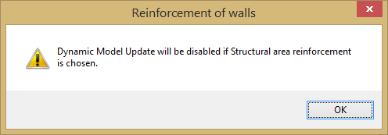

Note: Reinforcement will only be added to the layer indicated as a structural layer in a multi-layer wall. Otherwise, the reinforcement is distributed for the total thickness of the wall (covers are calculated for the total thickness).
If the Save data without reinforcement generation option is cleared, the reinforcing bars are generated and displayed in Autodesk® Revit®. If this option is selected, the reinforcement data is generated (and can be used after restarting the Extension), but reinforcing bars cannot be displayed in Autodesk® Revit®.

Distribution Bars
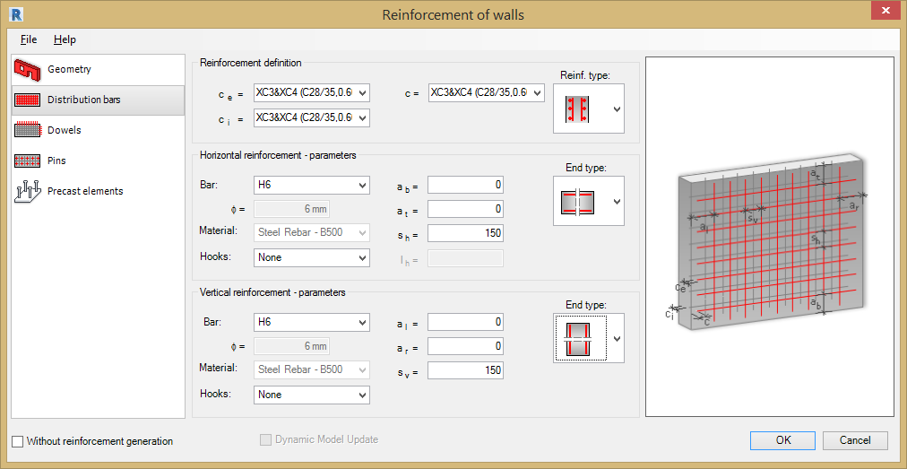
There are several parameters of distribution reinforcement defined in the Reinforcement of walls dialog:
Reinforcement definition
- c = Cover for the wall reinforcement bars (the cover is calculated along the wall length, from the ends of the wall).
- ce = For a horizontal bar of the reinforcement grid (covers defined for the wall thickness).
- ci = For a horizontal bar of the reinforcement grid (covers defined for the wall thickness).
- Reinforcement type - Choose the required layout from the drop down list.
Horizontal reinforcement parameters
- End type - Select the required layout for the reinforcing bars at the end of the wall.
- Bars - Bar Grade and Diameter.
- Material - Steel Grade for reinforcement.
- Hooks - Choose from None, 135 degrees, 90 degrees, 135 degrees seismic & 90 degrees seismic.
- ab = Offset distance of bottom horizontal bar.
- at = Offset distance of top horizontal bar.
- sh = Horizontal bar centres.
Vertical reinforcement parameters
- End type: The same as for horizontal reinforcement bars.
- Bars - Bar Grade and Diameter.
- Material - Steel Grade for reinforcement.
- Hooks - Choose from None, 135 degrees, 90 degrees, 135 degrees seismic & 90 degrees seismic.
- al = Offset distance of left vertical bar.
- ar = Offset distance of right vertical bar.
- sv = Vertical bar spacings.
Note: The cover value is taken into account in the values ab, at , al and ar:
- if at < Cover, then the cover value is adopted.
- if at > Cover, then the value at is adopted.
Parameters of bars are loaded from families defined in Revit®. A bar diameter and a material are associated with a selected steel grade (family).

Dowels
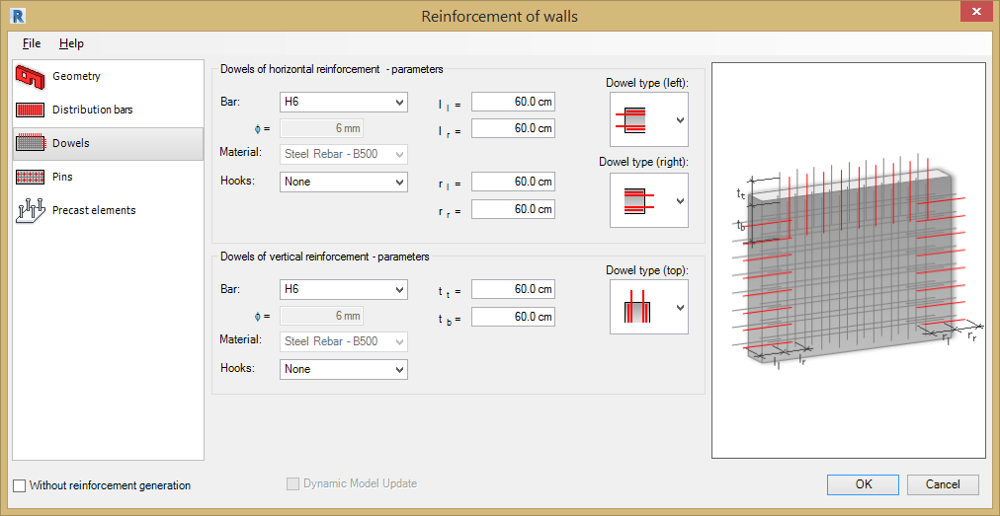
Define the parameters of the wall dowels in this tab, these include:
Dowels of horizontal reinforcement
- Bars - Bar Grade and Diameter.
- Material - Steel Grade for reinforcement.
- Hooks - Choose from None, 135 degrees, 90 degrees, 135 degrees seismic & 90 degrees seismic.
Bar length
- Dowel type: (left and right) - Select the required bar layout from the drop down menu.
Dowels of vertical reinforcement
- Bars - Bar Grade and Diameter.
- Material - Steel Grade for reinforcement.
- Hooks - Choose from None, 135 degrees, 90 degrees, 135 degrees seismic & 90 degrees seismic.
Bar length
- Dowel type: (from the top) - Select the required bar layout from the drop down menu.
Parameters of bars are loaded from families defined in Revit®. A bar diameter and a material are associated with a selected steel grade (family).

Pins
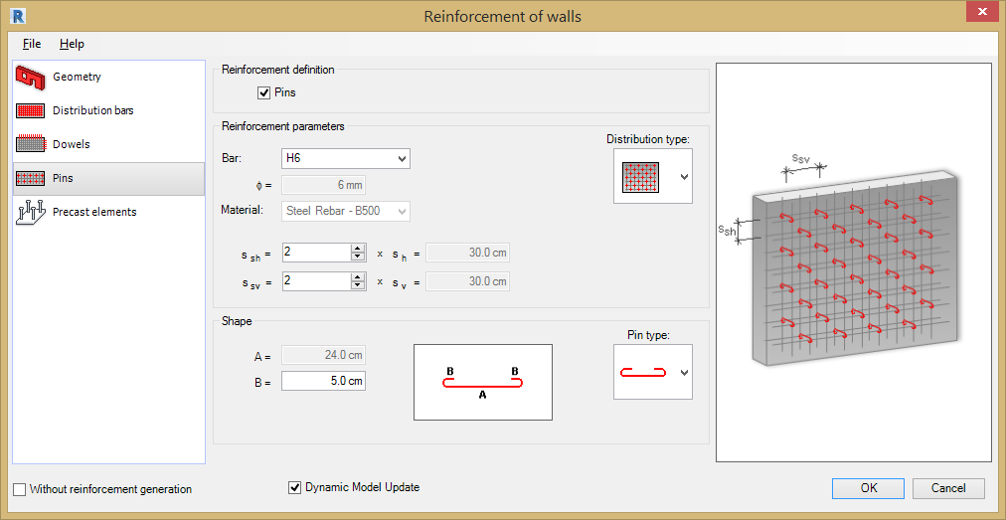
Define the parameters of the wall pins in this tab, these include:
Reinforcement definitions
- Pins – Select this option to add pin reinforcement to the wall.
Reinforcement parameters
- Distribution type -
- Bars - Bar Grade and Diameter.
- Material - Steel Grade for reinforcement.
- s sh = Horizontal spacing multiplier.
- s sv = Vertical spacing multiplier.
- x sh = Reported horizontal spacing distance.
- x sv = Reported vertical spacing distance.
Shape
- Pin type: -
- A = Nul.
- B = Type the required Dim B length.
Note: Characteristic dimensions (such as hook length) for a selected shape (editing pin length are unavailable because the software selects the pin length depending on wall thickness.

Seismic Reinforcement
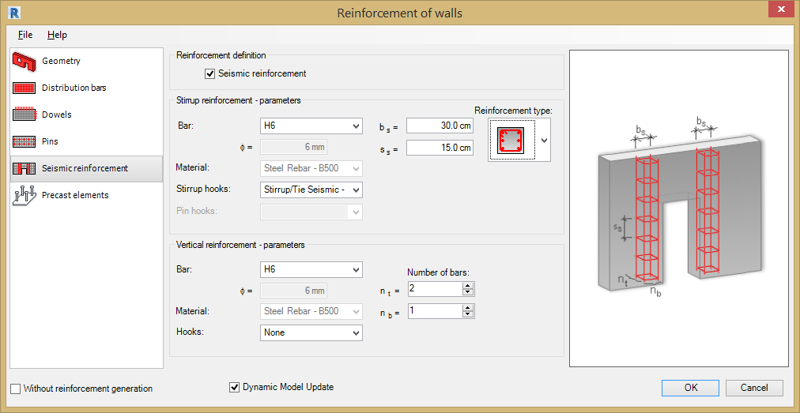
To generate the reinforcement of openings against seismic action, under Reinforcement definition, select Seismic reinforcement.
Reinforcement Definition
- Seismic reinforcement - Tick this option to add Seismic reinforcement.
This reinforcement type is available only if there is at least one opening in the wall. After you select this option, you can define parameters of seismic reinforcement:
Stirrup reinforcement
- Reinforcement type: Choose the required rebar layout from the drop down menu.
- Bars - Bar Grade and Diameter.
- Material - Steel Grade for reinforcement.
- Stirrup Hooks - Choose from None, 135 degrees, 90 degrees, 135 degrees seismic & 90 degrees seismic.
- Pin Hooks - Choose from None, 135 degrees, 90 degrees, 135 degrees seismic & 90 degrees seismic.
- ss = Stirrup spacing.
- bs = Column width (stirrup width).
Vertical reinforcement
- Reinforcement type:
- Bars - Bar Grade and Diameter.
- Material - Steel Grade for reinforcement.
- Hooks - Choose from None, 135 degrees, 90 degrees, 135 degrees seismic & 90 degrees seismic.
Number of bars: -
- n b = Select the number of vertical bars distributed along the wall.
- n h = Select the additional vertical bars.

User Reinforcement
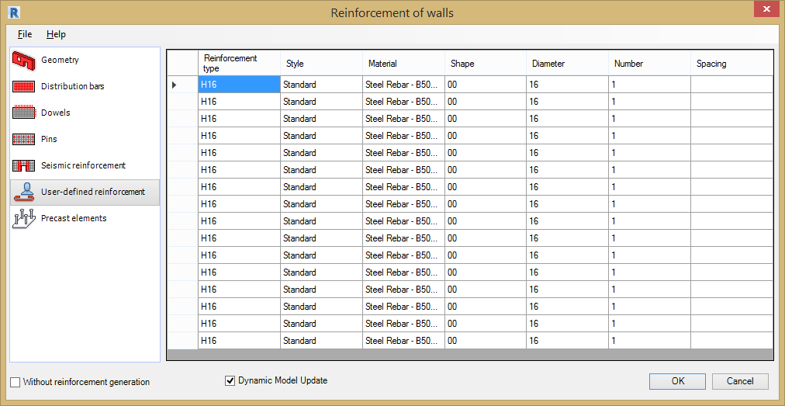
The User-defined dialog is displayed when a wall is selected that already contains reinforcement placed using the Revit® rebar tools.
The table displays information for the reinforcing bars already placed inside the beam:
- Reinforcement type - Bar Grade and Diameter.
- Style - Bar type, bent, straight or stirrup.
- Material - Steel Grade for reinforcement.
- Bar shape - Shape Code number.
- Bar diameter - Diameter of bar.
- Number - Number of bars.
- Spacing - Centre to centre spacing between bars.
The data in this table is displayed according to the rules used in Autodesk® Revit®.

Precast Elements
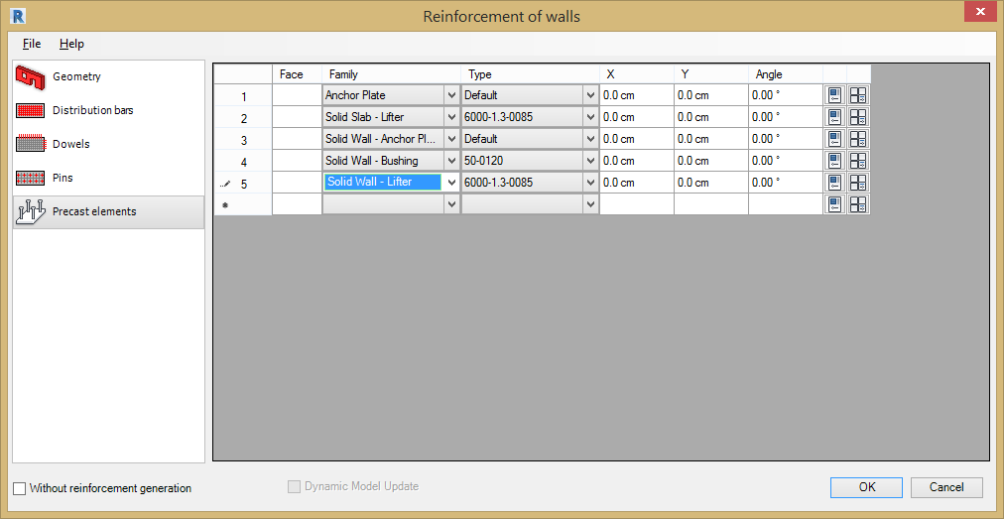
This tab is only available when precast elements exist in the Revit®. Precast elements can be imported to Revit® (Insert > Load from Library > Insert family).
The options in the tab allow for generation of additional elements of the wall reinforcement - steel precast elements (mounting parts). The precast elements are steel elements, added to the RC elements of the structure for particular purposes, e.g. in order to reduce heat loss and noise that is emitted.
In order to define a precast element in an RC wall, follow the steps below:
- From the list of the available faces of an RC element, select the section face of an RC wall; the list of available faces depends on the type of wall cross-section.
- Select the precast element family.
- Select the type of the precast element.
- Define the co-ordinates of the precast element insertion on the selected face of the element.
- The co-ordinates are measured in relation to the left, bottom corner of a face; the positive angle is clockwise.
- Define the properties of a family / precast element type.
- Click the icons located at the end of the definition of a precast element to open dialogs containing properties of a family or the element type.

